|  |
| --- |
| Texas Instruments |
| Keystone II Multicore Workshop |
| ARM-based Lab Manual |

February 2014

Contents

Prerequisites 1

Hardware 1

Software 1

KeyStone II Workshop Layout 2

Setting up a Serial Terminal Session to the EVM via USB 3

Setting up a VNC View to the Ubuntu Server 3

Lab 1: EVM Board Bring-up and OOB Demonstration 1

Purpose 1

Task 1: Loading the U-BOOT 1

Step 1: Verify the Current U-BOOT 1

Step 2: Program SPI NOR Flash with U-boot GPH image 2

Task 2: Load and Run Standard “Hello World” Application 3

Lab 2: Build a New ARM Program 9

Projects and source code 9

Purpose 9

Task 1: Modify the File system 9

Example Simple Code 10

Build the Executable 10

Unzip and Decompress the File System and add the new executable 11

Compress and Zip the New File System 12

Reboot the EVM and Run the New Program 12

Task 2 (optional): Build U-boot, Boot Monitor and Kernel 13

Step 1: U-BOOT Source Code Extraction 13

Step 2: U-BOOT Build Instructions 14

Step 3: Boot Monitor (skern.bin) Source Code Extraction & Build Instructions 15

Linux Kernel and Device Tree Source Code Extraction and Build Instructions 16

Lab 3: Boot Using NFS-mounted File System 17

Purpose 17

Task 1: Build a File System on a Linux Host using the NFS Server 17

Task 2: Configure U-BOOT to Mount the File Server and Boot 18

Task 3: Build and Debug a New C Program in the File System 19

Lab 4: Boot Using USB Flash Drive 22

Purpose 22

Task 1 – Preparing the USB 22

On Ubuntu Host 22

Task 2 – Reboot the EVM 24

Lab 5: Build, Run and Optimize DSP Project using CCS 35

Purpose 35

Project Files 35

Task 1: Build and Run the Project 35

Task 2: Define the Target 43

Create a new target in CCS 43

Task 3: Connect to the EVM 44

Task 4: Load and Run CASE 1 45

Task 5: Use Optimization and Disable Symbol Debug for the fir Filter Routine 46

Task 6: Optimize Software Pipeline 48

Task 7: Enable the Cache 50

Task 8: Running in Parallel on Multiple Cores 51

Lab 6: Load and Run DSP Code Using MPM Server 55

Purpose 55

Project Files 55

Task 1: Build and Run the Project 55

Task 2: Using MPM to load, run and observe results 58

Lab 7: ARM-DSP Communication Using MPM & Shared DDR 59

Purpose 59

Linux and DSP simple memory management 59

Project Files 62

Build and Run the Project 62

Lab 8: Build and Run ARM Code Using CCS on Linux 65

Purpose 65

Prerequisites 65

Task 1: CCS - Start a new cross compiler project and build it 65

Task 2: GDB from the tera-terminal 71

Move the Debug directory outside of CCS 71

Task 3: Connect a SSH terminal into the target 72

Task 4: Optional – Use gdb to debug the application 82

Task 5: Configure the host proxy 86

Lab 9: ARM Optimization Using SMP Linux 87

Projects and source code 87

Purpose 87

Task 1: Copy and observe the source files 87

Task 2: Compile and build the project, run it on a single core 88

Task 3: Run the Code on Multiple Cores 92

Lab 10: Inter-Processor Communication (IPC) 94

Projects and source code 94

Purpose 94

Task 1: Run the demo from a Web Server 94

Step 1 94

Step 2 94

Step 3 94

Task 2: Run the demo from the terminal 99

Purpose 99

Step 1 – Understand the file demo_ipc.sh 99

Step 2 – Run the file demo_ipc.sh 100

Task 3: Rebuild the Executable 101

Purpose 101

Step 1 – Get a private copy of IPC from the release 102

Step 2 – Build the ARM executable 102

Step 3 – Build the DSP executable 107

Task 4 – Optional: Modify source code and rebuild the executable 109

Purpose 109

Step 1 – Modify the ARM code 109

Step 2 – Build the ARM code 110

Step 3 – Modify the DSP code 110

Step 4 – Build the DSP code 111

Step 5 – Run the file demo_ipc.sh 111

Lab 11: Build U-boot, Boot Monitor and Kernel 112

U-BOOT source code extraction and build instructions 112

Boot Monitor (skern.bin) source code extraction and build instructions 113

Linux Kernel and device tree source code extraction and build instructions 114

# Prerequisites

The following hardware and software are needed to perform the labs in this manual.

## Hardware

Update BMC and UCD on EVMK2H (optional):

1. The wiki page <http://processors.wiki.ti.com/index.php/EVMK2H_Hardware_Setup> gives instructions on how to detect if the board needs BMC (Baseboard Management Controller) update. It also instructs how to do the update the BCM using CCS.  
     
   NOTE: A PDF version of the wiki page (KeyStone2_EVM_hardwareSetUp.pdf) is also available. Ask your instructor.
2. The user must also check the UCD Power Management version (see EVMK2H Hardware Setup at link above) and update if necessary.  
     
   NOTE: Instructions and scripts that show how to update the UCD are provided in the zip file XTCIEVMK2X-UCD-Update.zip (ask your instructor).

## Software

The following software packages are pre-installed on the student laptop before the workshop starts.  
NOTE: During the workshop, the laptop is attached to local network and has limited access to internet.

1. MCSDK and CCS
   1. The latest release of MCSDK is found here:  
      <http://software-dl.ti.com/sdoemb/sdoemb_public_sw/mcsdk/latest/index_FDS.html>  
        
      NOTE: Linux MCSDK was pre-installed on an Ubuntu server that will be used in some of the labs.
   2. From the same download page as the MCSDK, locate and download the latest CCS version and the emupack version that goes with the CCS. Follow the instructions on the page.  
        
      NOTE: Installing CCS requires a license from TI.
   3. For details regarding the instructions in this section, refer to the [MCSDK User Guide for KeyStone II](http://processors.wiki.ti.com/index.php/MCSDK_User_Guide_for_KeyStone_II).
2. **VNC Viewer:** A VNC server that supports graphic interface was installed on the Ubuntu server. Each laptop has VNC viewer installed to communicate with the VNC server. Limited functionality Real VNC viewer is available as freeware from multiple sites.
3. **FTP server** is installed on the Ubuntu server. Moving files between the student laptop and the Ubuntu server can be done with the enterprise version of Real VNC or (if the student uses a freeware real VNC) by using FTP client on the laptop.
4. For communication between the student PC and the EVM, the **FTDI Driver** is required. As needed, download the 32-bit driver here: <http://www.ftdichip.com/Drivers/D2XX.htm>

### KeyStone II Workshop Layout

Figure : Workshop Network Layout



Figure 1 shows the workshop network environment:

* There are up to 11 lab stations. EVMs at each station are numbered from 1 to 11. Each station has the following:
  + One EVMK2H
  + One laptop that is connected to the EVM via JTAG cable, called the first laptop.
  + One optional laptop that is not connected to the EVM, called the second laptop in the station.
* All EVMs and students laptops are connected to the local network 192.168.0.XX via a wired connection to a switch or a router.
* The Ubuntu server is connected as well. The Ubuntu server (or a router) has access to an external network with a global IP that have access to the Web. The IP address may be given by DHCP server on the Ubuntu or DHCP server on a router.

### Setting up a Serial Terminal Session to the EVM via USB

The EVM has two (mini) USB ports.

* + One of the ports accesses the JTAG connection and can be used to connect CCS to the board. This USB connector is part of the emulator daughter (mezzanine) card.
  + The second USB port is part of the mother board and can be used to connect two serial terminals into the EVM. We will refer to these serial terminals as Tera-Terminal (to distinguish from the window viewer terminal to the Ubuntu machine). The tera-terminals are connected using a single USB cable but can be opened as two tera-terminals.
    - The first serial terminal (ARM Tera-terminal) is connected to the ARM terminal (e.g., the lower COM port)
    - The second serial terminal (BMC Tera-terminal) is connected to the FPGA/BMC on the board.
    - The user must open the two tera-terminals and set the serial rate to 115200 Baud.

### Setting up a VNC View to the Ubuntu Server

1. Launch the VNC Viewer application from the desktop of your laptop/PC.
2. The server IP will be given by the instructor. For static configuration, when DHCP is not available, the server IP is 192.168.0.100.

* The login instance for student N is :N. For example, student 3 will VNC to address 192.168.0.100:3, while student number 7 will use 192.168.0.100:7.
* The VNC password for all students is “vncserve ”

# Lab 1: EVM Board Bring-up and OOB Demonstration

## Purpose

The purpose of this lab is to complete the out-of-box (OOB) demonstration that shows how to boot and run a very basic “hello world” program using U-BOOT. You will load the kernel and file server and run a pre-built hello world application.

## Task 1: Loading the U-BOOT

The U-BOOT that is programmed into flash on the EVM may need to be updated when moving to the most recent version of the MCSDK. First, determine which version of U-BOOT is currently programmed into flash. Second, load the current U-BOOT image into SPI NOR flash, as needed.

### Step 1: Verify the Current U-BOOT

To verify if the U-BOOT is already loaded, perform the following steps:

1. Set Dip Switch (SW1) on the EVM to 1 OFF 2 OFF 3 ON 4 OFF
2. Open two terminals into the EVM using a single USB cable connected to the lower USB connection on the board. From serial port setting chose Baud rate of 115200
3. Power up the EVM. If the U-BOOT is already burned into the flash, the terminal will look like the following:

**U-Boot SPL 2013.01 (Apr 05 2013 - 14:12:32)**

**SF: Detected N25Q128A with page size 64 KiB, total 16 MiB**

**U-Boot 2013.01 (Apr 05 2013 - 14:12:32)**

I2C: ready

DRAM: 1 GiB

WARNING: Caches not enabled

NAND: 512 MiB

Net: Ethernet PHY: 88E1111 @ 0x00

TCI6614-EMAC

Warning: failed to set MAC address

Hit any key to stop autoboot: 0

### Step 2: Program SPI NOR Flash with U-boot GPH image

The following process is used to update the U-BOOT image in SPI Flash:

1. Power cycle the EVM and stop the autoboot by pressing any key.
2. Copy **u-boot-spi.gph** from the images in the MCSDK release to the tftp server root directory.  
     
   NOTE: When using the standard training server, **u-boot-spi.gph** should be copied to directory **/var/lib/tftpboot/studentN** where N is the student number. Then add path to studentN, e.g., **dhcp 0xc300000 studentN/u-boot-spi-keystone-evm.gph**
3. Rename the image file to **u-boot-spi-keystone-evm.gph**
4. Make sure the tftp server is running. Then issue the following commands to U-Boot console:

**setenv serverip <your tftp address>**

**dhcp 0xc300000 u-boot-spi-keystone-evm.gph**

**sf probe**

**sf erase 0 <size of u-boot-spi.gph in hex up rounded to sector boundary of 0x10000>**

**sf write 0xc300000 0 <size of u-boot-spi.gph image in hex>**

NOTE: The size of the image will be displayed as part of the DHCP command.

NOTE: If **u-boot-spi.gph** was not copied to tftp root directory, then specify the path

e.g.: **dhcp 0xc300000 release/u-boot-spi-keystone-evm.gph**

## Task 2: Load and Run Standard “Hello World” Application

1. In order for the U-BOOT to get files from a sub-directory, the tftp download path for u-boot command needs to be specified via the **tftp_root** value. For example, if all the files that are needed for U-BOOT are in directory **/var/lib/tftpboot/studentN**, then the tftp_root value of the U_BOOT is **studentN**

* The base location of the tftp server is defined in the tftp configuration file (**/etc/xinetd.d/tftp**) as the **server_args**.
* The default setting is **/var/lib/tftpboot/studentN** where N is the student number assigned to you in this lab.

1. Make a subdirectory **/var/lib/tftpboot/studentN** if it does not exist already and copy the MCSDK release binary images into this directory. The binary images are located in the following directory on the Ubuntu server:

**cd /var/lib/tftpboot/studentN**

Where N is the student number you have been assigned for this lab.

**cp /opt/ti/MCSDK_3_XX/mcsdk_linux_3_00_0X_XX/images/*.* .**

Where 0X_XX is the most current MCSDK release number (e.g., 03_15)

1. You can also move the images from the release of MCSDK on your laptop using FTP. Use the same directory: **cd /var/lib/tftpboot/studentN**
2. U-BOOT loading and running Linux Kernel using TFTP with ramfs file system
   1. First set the DIP switch (sw1) to ARM SPI boot mode:  
      1 OFF 2 OFF 3 ON 4 OFF (for Rev 1 EVM)
   2. Power off EVM
   3. Disconnect CCS from EVM (if already connected)
   4. Power up EVM, look at the ARM tera-terminal window

1. It is very important to set the environment variables correctly for U-BOOT. Here are the instructions how to do so:
   1. After power cycle, press ESC to stop autoboot in the ARM tera-terminal
   2. Enter the following command to reset the current environment variables.

**env default -f –a**

* 1. The file system used in this example is **tisdk-rootfs.cpio.gz** is larger than 9MB. So you need to update the server arguments to accommodate it.  
     NOTE: The size limitation is 80 MB.

**setenv args_ramfs 'setenv bootargs ${bootargs} earlyprintk rdinit=/sbin/init rw root=/dev/ram0 initrd=0x802000000,80M'**

* 1. Set the following environment variables:
* **setenv name_fs**the name of the compressed file system to load. e.g.,**tisdk-rootfs.cpio.gz** (look at the release for an updated name)
* **setenv name_fdt** the name of the binary device tree. e.g., **uImage-k2hk-evm.dtb** (look at the release for an updated name)
* **setenv name_kern** the name of the kernel file. e.g., **uImage-keystone-evm.bin** (look at the release for an updated name)
* **setenv name_mon**the name of the kernel monitoring file. e.g., **skern-keystone-evm.bin** (look at the release for an updated name)
* **setenv serverip**IP address of the TFTP server (the Ubuntu server, default IP for workshop is 192.168.0.100)
* **setenv boot ramfs**
* **setenv tftp_root studentN**
* **saveenv**
  1. Boot the EVM using either a hardware or software reboot.
* Hardware reboot = power cycle
* Software reboot = type **reboot** in the BMC terminal window
* From U-boot prompt, type **boot**

1. The tera-terminal will start as follows:

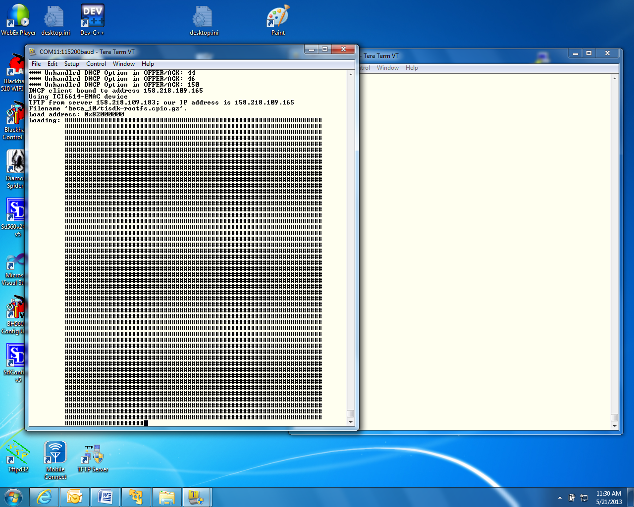

1. When booting ends, login as **root** (no password)

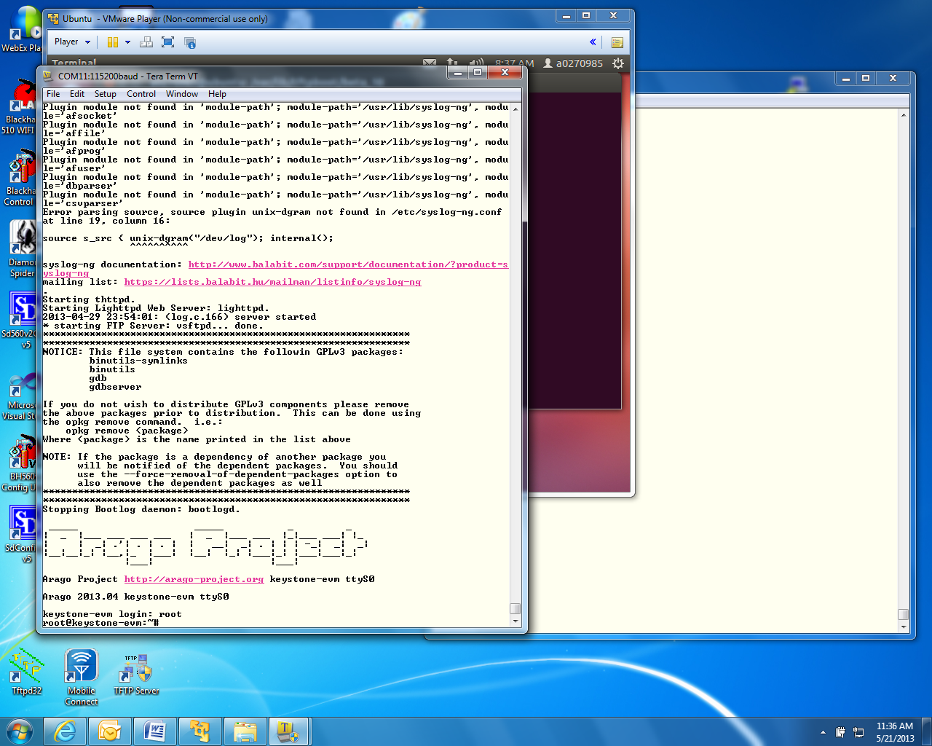

1. Run the hello program **hello**
2. The program should print hello world on the tera-terminal.

# Lab 2: Build a New ARM Program

## Projects and source code

Unless instructed by the instructor otherwise, all projects and source code are available on the Ubuntu server. The directory **/usr/local/projects** has two sub-directories:

* **/usr/local/projects/ARM** contains ARM projects
* **/usr/local/projects/DSP** contains DSP projects

NOTE: When the DSP projects are built using CCS on the student PC, projects should be moved via FTP from the server to the student laptop.

## Purpose

The purpose of this lab is to demonstrate how to build and run a simple ARM program using all the development tools on Ubuntu server. You will then load the new file server to the EVM and execute the code.

## Task 1: Modify the File system

First, you will modify the file system that was previously loaded onto the EVM. A complete build of all other images that are part of the release is an optional exercise. The instructions how to build the U-Boot, boot monitor and the kernel images are provided in Task 2.

Modifying the file system involves three steps:

1. First, a new main function is developed. Using the cross compiler tools on Ubuntu, the function is compiled and an executable is built.
2. Next, the current compressed file system is unzipped and de-compressed into a temporary directory, and the new executable that was built in the previous step is added.
3. Last, the new file system is compressed, zipped, and moved to the tftp directory. The EVM is then booted, the new program is executed, and produces the expected results.

### Example Simple Code

The instructor will provide you with a simple C program that does elementary calculations and prints out some comments and the results of the calculations.

1. For the standard TI workshop, the example code is located on the Ubuntu server in **/usr/local/projects/ARM** directory. Assume that the example file name is **example1.c  
     
   NOTE: If the example code name is different, substitute the correct name for example1 throughout the process outlined in this document.**
2. Copy this file to the student directory **/home/studentN/temp**

NOTE: If the temp directory does not exist, create it as follows:

* **cd ~** takes you to the home directory
* **mkdir temp**
* **cd temp**

1. **/usr/local/studentStartScript.sh** is a script that defines all the paths and exports for each individual user. The user must call this script for each new terminal:  
     
   **source /usr/local/studentStartScript.sh**
2. The Linaro toolchain and all other shared software are installed on the Ubuntu server in directory **/usr/local/.** A path to the Linaro tool chain is defined in the script **studentStartScript.sh**.

### Build the Executable

1. To use the cross compiler to build the executable, cd the terminal to the directory where **example1.c** was stored and use the following command:   
     
   **arm-linux-gnueabihf-gcc -o example1 –g example1.c**  
     
   The cross compiler tools will compile the file and build an executable called **example1** in the same directory.
2. To verify that the compilation was done for the ARM processor and not for the native Intel (or other) processors do the following:  
     
   **file example1**
3. The results should show the ARM architecture:   
     
   **“example1: ELF 32-bit LSB executable, ARM, version 1 (SYSV), dynamically linked (uses shared libs), for GNU/Linux 2.6.31, BuildID[sha1]=0x953dac672e7159d481d5a6d3bbb5356e5f870d21, not stripped”**

### Unzip and Decompress the File System and add the new executable

The compressed file system has a cpio.gz extension (the current release name for the file system is tisdk-rootfs.cpio.gz)

1. If it does not already exist, create a new directory **/opt/filesys/studentN**

**sudo mkdir /opt/filesys/student**

NOTE: When **sudo** is used, the system may prompt for a password.  
Password = **WsN** (where N is your student number)

**cd /opt/filesys/studentN**

1. Copy the current compressed file system to the new directory:

**sudo cp /var/lib/tftpboot/studentN/tisdk-rootfs.cpio.gz** .

1. Unzip the compressed file system

**sudo gzip –d tisdk-rootfs.cpio.gz** (or name of the file system that you choose)

1. Uncompress the file system from the cpio file. This operation builds the complete file system. NOTE: The compressed file tisdk-rootfs.cpio is still in the directory   
     
   **sudo cpio –i –F tisdk-rootfs.cpio**
2. Remove tisdk-rootfs.cpio

**sudo rm tisdk-rootfs.cpio**

1. Copy the executable that was built previously (example1) into the **usr/bin** directory in the file system. The complete path is **/opt/filesys/studentN/usr/bin**

**sudo cp <example1DirectoryLocation>/example1 /opt/filesys/studentN/usr/bin/.**

### Compress and Zip the New File System

1. The next step is to compress the file system back into a new file system. This is done by piping all the directories and the files in the file system into the cpio. The resulted compressed file system will be copied to one directory above:

**cd /opt/filesys/studentN**

**sudo chmod -R 777 \*** (Provides read/write/execution permission  
 to all files and subdirectories)

**sudo find . | sudo cpio –H newc –o –O <new.cpio>**

Where **<new.cpio>** is the new compressed file system

1. To zip the new file system, do the following:

**sudo gzip new.cpio** (this will generate a file new.cpio.gz)

**sudo cp new.cpio.gz /var/lib/tftpboot/studentN/.**

1. At this point, studentN has two file systems. There are several options for making the new one active:
   1. The user can change the environment variable **name_fs** in the EVM U-BOOT to **new.cpio.gz**
   2. The user can delete the previous **tisdk-rootfs.cpio.gz**, and then change the name of **new.cpio.gz** to **tisdk-rootfs.cpio.gz**
   3. The user can change the name of **new.cpio.gz** to any other name (with the .cpio.gz extension) like **tisdk-rootfs-example1.cpio.gz**, and change the environment variable **name_fs** in the EVM U-BOOT to the new name.

### Reboot the EVM and Run the New Program

1. Reboot the EVM with the new file system.
2. After boot, login as a **root**.
3. Go to **/usr/bin** and run example1.
4. Observe the results.

## Task 2 (optional): Build U-boot, Boot Monitor and Kernel

Linux distribution enables users to download all source code and build the Linux components. This optional task gives instructions how to do so.

TI uses the Arago distribution on a public server to store all source code. The user can download all the sources and make files to build all images in the release. The Ubuntu server must be connected to the network to facilitate downloading of the source code. If the server is behind a firewall, proxies must be set. These proxies are defined already in the **/usr/local/studentStartScript.sh** script.

### Step 1: U-BOOT Source Code Extraction

Before getting the source, the user must be in his home directory. Cloning the source code will generate sub-directories.

1. **cd ~/** back into the home directory /home/student
2. **git clone git://arago-project.org/git/projects/u-boot-keystone.git**This instruction will clone the repository into your local directory **~/u-boot-keystone**
3. **cd u-boot-keystone** Change directory to where the source is located
4. **git reset --hard <label>** Where label is the label that is attached to the current release. To find the head label, the user should look at the release notes. For MCSDK 3_14 the label is ***K2_UBOOT_2013-01_13.09_01*. S**o the reset instruction for the current release will be the following:

**git reset –hard K2_UBOOT_2013-01_13.09_01**

### Step 2: U-BOOT Build Instructions

Different versions of the U-BOOT can be built, depending on how the code is loaded. U-BOOT can be loaded from Code Composer Studio or from boot methods. The format can either be u-boot.bin, u-boot.img, u-boot-spl.bin or u-boot-spi.gph

* Option A: if using CCS to load (u-boot.bin)

**make tci6638_evm_config**

**make**

* Option B: if using the two stage SPI NOR boot

**make tci6638_evm_config**

**make spl/u-boot-spl.bin**

**make tci6638_evm_config**

**make u-boot.img**

**make tci6638_evm_config**

**make u-boot-spi.gph**

### Step 3: Boot Monitor (skern.bin) Source Code Extraction & Build Instructions

Before getting the source, the user must be in his home directory. Cloning the source code will generate sub-directories.

1. **cd ~/** back into the home directory /home/student
2. **git clone git://arago-project.org/git/projects/** **boot-monitor.git**  
   This instruction will clone the repository into your local directory **~/boot-monitor**
3. **cd boot-monitor** change directory to where the source is located
4. **git reset --hard <label>** Where label is the label that is attached to the current release. To find the head label, the user should look at the release notes. For MCSDK 3_14 the label is ***K2_BM_13.08*. S**o the reset instruction for the current release will be the following:

**git reset –hard K2_BM_13.08**

1. Build the boot monitor:  
    make clean  
    make

### Linux Kernel and Device Tree Source Code Extraction and Build Instructions

Before getting the source, the user must be in his home directory. Cloning the source code will generate sub-directories.

1. **cd ~/** back into the home directory /home/student
2. **git clone git://arago-project.org/git/projects/** **linux-keystone.git**This instruction will clone the repository into your local directory **~/boot-monitor**
3. **cd linux-keystone C**hange directory to where the source is located
4. **git reset --hard <label>** Where label is the label that is attached to the current release. To find the head label, the user should look at the release notes. For MCSDK 3_14, the label is ***K2_LINUX_03.08.04_13.09_01*. S**o the reset instruction for the current release will be the following:

**git reset –hard K2_LINUX_03.08.04_13.09_01**

1. Build the files:  
     
   **make keystone2_defconfig  
     
   make uImage  
     
   make keystone-sim.dtb  
     
   make tci6638-evm.dtb**

The built files:

**vmlinux** is in **/linux-keystone** folder:

**uImage & *.dtb** are in **/linux-keystone/arch/arm/boot** folder

# Lab 3: Boot Using NFS-mounted File System

## Purpose

The purpose of this lab is to demonstrate how to boot the EVM when the file system resides on a different server that is mounted on the EVM, then develop code on the Linux host and move it to the file system. The executable will be available to the ARM on the EVM. A debug session using gdb will be performed from the serial port terminal.

## Task 1: Build a File System on a Linux Host using the NFS Server

The NFS server is installed on the Ubuntu server in the directory /opt/filesys. Each student has a sub-directory where he or she builds the file server, and the Uboot is configured to reach this directory for each student. The file system to be mounted should be built on the local Ubuntu machine.

1. Create a directory where the file system resides; say **/opt/filesys/studentN** (where N is the student number). **NOTE: This directory should already exist.**
2. Copy a tar version of the compressed file system **tisdk-rootfs.tar.gz** (part of the release in the images directory) into **/opt/filesys/student**
3. Untar the file system: **sudo tar zxf tisdk-rootfs.tar.gz**
4. Delete the original compress file: **sudo rm tisdk-rootfs.tar.gz**
5. Add the file system directory to the exports list. Open the file **/etc/exports** and add the following line to it (or simply verify that it is already there):  
     
   **/opt/filesys *(rw,subtree_check,no_root_squash,no_all_squash,sync)**

The file **/etc/exports** should appear as follows:

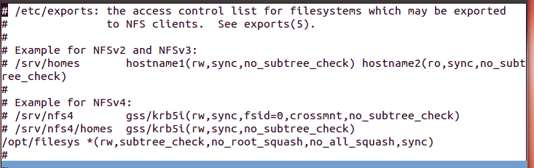

1. The instructor will start the NFS server.

## Task 2: Configure U-BOOT to Mount the File Server and Boot

1. Power cycle the EVM. In the ARM tera-terminal window, stop the autoboot.
2. Change the following environment variables:  
   1. Change the boot to be from the network :  
       **setenv boot net**
   2. Add the nfs server ip  
       **setenv nfs_serverip xxx.xxx.xxx.xxx**   
        
      Where xxx.xxx.xxx.xxx is the IP address of the Ubuntu server on which the file system resides. For the standard workshop, the address is 192.168.0.100
   3. Define the file system root directory:  
        
      **setenv nfs_root /opt/filesys/student**
   4. Configure the arguments for the boot:   
        
      **setenv args_net 'setenv bootargs ${bootargs} rootfstype=nfs root=/dev/nfs rw nfsroot=${nfs_serverip}:${nfs_root},${nfs_options} ip=dhcp'**
   5. Save the new environment variables:  
        
      **saveenv**
3. Boot the EVM.  
     
   NOTE: If the DHCP does not supply an IP address to the EVM, the EVM will use its default IP address. This default IP address is defined in the environment variables as **ipaddr**. If this does not exist, the user can configure it using **setenv ipaddr yyy.yyy.yyy.yyy**

## Task 3: Build and Debug a New C Program in the File System

1. In a local viewer to the Ubuntu, go to **/opt/filesys/studentN** and look at the file system.
2. Follow the Example Simple Code section of the previous lab to copy example1.c into one of the directories of the file system (For example, **/opt/filesys/studentN/bin**).  
     
   NOTE: You may need to modify permissions of the bin directory as follows:  
     
   **sudo chmod 777 /opt/filesys/studentN/bin**
3. Set the terminal in the bin directory: **cd /opt/filesys/student/bin**
4. Compile and build the application similar to the method used in the previous lab, but add the debug flag (**-g**) to the command:  
     
   **arm-linux-gnueabi-gcc –g -o example1 example1.c**
5. Back to the tera-terminal, navigate to the /bin directory: **cd /bin**
   1. Make sure that example1.c and example1 are both in the bin directory  
        
      **ls –ltr example1\***
   2. Start a debug session:  
        
      **gdb example1**
   3. Simple gdb commands:
      * **list** see the source
      * **b** set a break point
      * **r** run to the break point
      * **s** step
      * **n** next (step over)
      * **c** run to the next breakpoint
      * **finish** end
   4. There are many gdb quick guides on the Web. Here is a URL to one of them:

<http://condor.depaul.edu/glancast/373class/docs/gdb.html>

# 

# Lab 4: Boot Using USB Flash Drive

## Purpose

The purpose of this lab is to demonstrate how to boot the EVM from a USB flash drive. The Kernel, monitor, and device tree reside on one partition of the USB. The file system resides on a second partition.

NOTE – USB boot is not available on release 2 and 3 of the EVM unless they were changed to supply the USB with power. Release 1.1 of the EVM has USB power.

## Task 1 – Preparing the USB

NOTE: This procedure was already done. The instructor will provide pre-prepared USB memories.

### On Ubuntu Host

#### I - Install gparted

$sudo apt-get install gparted

Used GParted 0.11.0 for this test. So exact steps may vary if version is different

#### II - Partition the device

Use partition 1 for boot images and Partition 2 for rootfs

insert the usb flash drive to usb slot

$sudo gparted

The GUI will show up now. Choose correct device (/dev/sdx) at the top right corner (shows the correct size of the usb drive). This example uses /dev/sdc1 for partion 1 and /dev/sdc2 for partition 2

Warning!! Before you proceed, make sure you selected the correct device, otherwise it may format the active harddisk partition of your PC

Got to top level "Partition" pulldown menu and select Unmount to unmount the device. If there is existing partition, delete the same (Partition -> delete)

Now Partition and filesystem status shows as unallocated

1. Create fat32 partion for boot (contains boot images)

Partition -> new

New size = 32MiB

File system = fat32

label = boot

Keep rest of the fields default

click add to add partition

select the partiton #1 just created and format it (Partition -> format to).

select fat32 format

2. Create ext4 format for rootfs (contains root filesystem)

select the unallocate partition

Partition -> new

File system = ext4

label = rootfs

Keep rest of the fields default

click add to add partition

select the partiton #2 just created and format it (Partition -> format to).

select ext4 format

3. Apply the changes and Quit

Edit -> Apply All Operations

GParted -> Quit

#### III - Copy images and rootfs files to partitions

Unmount if the devices are automounted

$sudo umount /dev/sdc1

$sudo umount /dev/sdc2

1. Copy images to partition #1 (boot)

$sudo mount -t vfat /dev/sdc1 /mnt/test

Assume all images are available at the current directory

$sudo cp skern-keystone-evm.bin /mnt/test/

$sudo cp uImage-k2hk-evm.dtb /mnt/test/

$sudo cp uImage-keystone-evm.bin /mnt/test/

$ls /mnt/test

skern-keystone-evm.bin uImage-k2hk-evm.dtb uImage-keystone-evm.bin

$sudo umount /dev/sdc1

2. Copy rootfs files to partition #2 (rootfs)

$mdir test

$cd test

$gunzip <path of arago-console-image.cpio.gz>

$sudo cpio -i -F ../arago-console-image.cpio

$sudo mount -t ext4 /dev/sdc2 /mnt/test

$cd ..

$sudo cp -r test/* /mnt/test

$ls /mnt/test/

bin boot dev etc home init lib lost+found media mnt proc sbin srv sys tmp usr var

$sudo umount /dev/sdc2

## Task 2 – Reboot the EVM

#### Setup u-boot env variables

Insert USB flash drive to usb slot on EVM and Power ON EVM Tpe the following commands to setup the env for usb boot

>setenv boot usb

>setenv args_usb 'setenv bootargs ${bootargs} rootfstype=ext4 root=/dev/sda2 rw ip=dhcp'

>setenv init_usb 'usb start; run set_fs_none args_all args_usb'

>setenv get_fdt_usb 'fatload usb 0:1 ${addr_fdt} ${name_fdt}'

>setenv get_kern_usb 'fatload usb 0:1 ${addr_kern} ${name_kern}'

>setenv get_mon_usb 'fatload usb 0:1 ${addr_mon} ${name_mon}'

>saveenv

>boot

Here is the log using a USB 3.0 device. Boot takes about 1 minute

U-Boot 2013.01-00009-gd274e3f-dirty (Aug 29 2013 - 12:10:33)

I2C: ready

DRAM: 1 GiB

NAND: 512 MiB

Net: TCI6638_EMAC, TCI6638_EMAC1

Hit any key to stop autoboot: 0

(Re)start USB...

USB0: No power optimization available

Register 2001040 NbrPorts 2

Starting the controller

USB XHCI 1.00

scanning bus 0 for devices...

2 USB Device(s) found

scanning usb for storage devices... 1 Storage Device(s) found

reading uImage-k2hk-evm.dtb

44562 bytes read in 1067 ms (40 KiB/s)

reading skern-keystone-evm.bin

45056 bytes read in 949 ms (45.9 KiB/s)

reading uImage-keystone-evm.bin

3989320 bytes read in 48025 ms (81.1 KiB/s)

## installed monitor, freq [194560000], status 0

## Booting kernel from Legacy Image at 88000000 ...

Image Name: Linux-3.8.4-rt2-01225-g62655f8

Created: 2013-08-30 14:33:02 UTC

Image Type: ARM Linux Kernel Image (uncompressed)

Data Size: 3989256 Bytes = 3.8 MiB

Load Address: 80008000

Entry Point: 80008000

Verifying Checksum ... OK

## Flattened Device Tree blob at 87000000

Booting using the fdt blob at 0x87000000

Loading Kernel Image ... OK

OK

Using Device Tree in place at 87000000, end 8700de11

Starting kernel ...

[ 0.000000] Booting Linux on physical CPU 0x0

[ 0.000000] Linux version 3.8.4-rt2-01225-g62655f8 (a0868495@ares-ubuntu.am.dhc

p.ti.com) (gcc version 4.7.3 20130226 (prerelease) (crosstool-NG linaro-1.13.1-4.7

-2013.03-20130313 - Linaro GCC 2013.03) ) #3 SMP PREEMPT RT Fri Aug 30 10:32:50 ED

T 2013

[ 0.000000] CPU: ARMv7 Processor [412fc0f4] revision 4 (ARMv7), cr=30c7387d

[ 0.000000] CPU: PIPT / VIPT nonaliasing data cache, PIPT instruction cache

[ 0.000000] Machine: KeyStone2, model: Texas Instruments Keystone 2 SoC

[ 0.000000] switching to high address space at 0x800000000

[ 0.000000] cma: CMA: reserved 16 MiB at 1f000000

[ 0.000000] Memory policy: ECC disabled, Data cache writealloc

[ 0.000000] PERCPU: Embedded 9 pages/cpu @c0bd2000 s12864 r8192 d15808 u36864

[ 0.000000] Built 1 zonelists in Zone order, mobility grouping on. Total pages

: 130048

[ 0.000000] Kernel command line: console=ttyS0,115200n8 rootwait=1 rootwait=1 r

ootfstype=ext4 rootwait root=/dev/sda2 rw ip=dhcp

[ 0.000000] PID hash table entries: 2048 (order: 1, 8192 bytes)

[ 0.000000] Dentry cache hash table entries: 65536 (order: 6, 262144 bytes)

[ 0.000000] Inode-cache hash table entries: 32768 (order: 5, 131072 bytes)

[ 0.000000] __ex_table already sorted, skipping sort

[ 0.000000] Memory: 512MB = 512MB total

[ 0.000000] Memory: 495164k/495164k available, 29124k reserved, 0K highmem

[ 0.000000] Virtual kernel memory layout:

[ 0.000000] vector  : 0xffff0000 - 0xffff1000 ( 4 kB)

[ 0.000000] fixmap  : 0xfff00000 - 0xfffe0000 ( 896 kB)

[ 0.000000] vmalloc : 0xe0800000 - 0xff000000 ( 488 MB)

[ 0.000000] lowmem  : 0xc0000000 - 0xe0000000 ( 512 MB)

[ 0.000000] pkmap  : 0xbfe00000 - 0xc0000000 ( 2 MB)

[ 0.000000] modules : 0xbf000000 - 0xbfe00000 ( 14 MB)

[ 0.000000] .text : 0xc0008000 - 0xc070243c (7146 kB)

[ 0.000000] .init : 0xc0703000 - 0xc0742240 ( 253 kB)

[ 0.000000] .data : 0xc0744000 - 0xc078b8e0 ( 287 kB)

[ 0.000000] .bss : 0xc078b8e0 - 0xc07b63ac ( 171 kB)

[ 0.000000] SLUB: Genslabs=11, HWalign=64, Order=0-3, MinObjects=0, CPUs=4, Nod

es=1

[ 0.000000] Preemptible hierarchical RCU implementation.

[ 0.000000] NR_IRQS:16 nr_irqs:16 16

[ 0.000000] ipc irq: irqchip registered, range 512-539

[ 0.000000] main_pll_clk rate is 1167360000, postdiv = 2, mult = 18,prediv = 0

[ 0.000000] pll_clk parent_rate(122880000 Hz), rate(327680000 Hz),postdiv = 6,

mult = 15, prediv = 0

[ 0.000000] tci6614-timer: no matching node

[ 0.000000] Architected local timer running at 194.56MHz (phys).

[ 0.000000] Switching to timer-based delay loop

[ 0.000000] sched_clock: 32 bits at 194MHz, resolution 5ns, wraps every 22075ms

[ 0.000000] Console: colour dummy device 80x30

[ 0.000145] Calibrating delay loop (skipped), value calculated using timer freq

uency.. 389.12 BogoMIPS (lpj=1945600)

[ 0.000148] pid_max: default: 4096 minimum: 301

[ 0.000300] Mount-cache hash table entries: 512

[ 0.011993] CPU: Testing write buffer coherency: ok

[ 0.012169] CPU0: thread -1, cpu 0, socket 0, mpidr 80000000

[ 0.012204] Setting up static identity map for 0x80517268 - 0x8051729c

[ 0.182030] CPU1: Booted secondary processor

[ 0.182044] CPU1: thread -1, cpu 1, socket 0, mpidr 80000001

[ 0.261490] CPU2: Booted secondary processor

[ 0.261504] CPU2: thread -1, cpu 2, socket 0, mpidr 80000002

[ 0.341575] CPU3: Booted secondary processor

[ 0.341590] CPU3: thread -1, cpu 3, socket 0, mpidr 80000003

[ 0.341652] Brought up 4 CPUs

[ 0.341674] SMP: Total of 4 processors activated (1556.48 BogoMIPS).

[ 0.360841] NET: Registered protocol family 16

[ 0.384047] DMA: preallocated 256 KiB pool for atomic coherent allocations

[ 0.395928] keystone2_pcie_serdes_setup

[ 0.397997] keystone2_pcie_serdes_setup done

[ 0.398015] hw-breakpoint: found 5 (+1 reserved) breakpoint and 4 watchpoint re

gisters.

[ 0.398021] hw-breakpoint: maximum watchpoint size is 8 bytes.

[ 0.411553] bio: create slab <bio-0> at 0

[ 0.411792] keystone-pcie: keystone_pcie_rc_init - start

[ 0.411941] MEM 0x0000000050000000..0x000000005fffffff -> 0x0000000050000000

[ 0.411952] IO 0x0000000024000000..0x0000000024003fff -> 0x0000000000000000

[ 0.411993] pcie - number of legacy irqs = 4

[ 0.412054] pcie - number of MSI host irqs = 8, msi_irqs = 32

[ 0.522253] keystone-pcie: Doing PCI Setup...Done

[ 0.522260] keystone-pcie: Starting PCI scan...

[ 0.522425] PCI host bridge to bus 0000:00

[ 0.522438] pci_bus 0000:00: root bus resource [mem 0x50000000-0x5fffffff]

[ 0.522446] pci_bus 0000:00: root bus resource [io 0x0000-0x3fff]

[ 0.522454] pci_bus 0000:00: No busn resource found for root bus, will use [bus

00-ff]

[ 0.522497] PCI: bus0: Fast back to back transfers enabled

[ 0.522515] keystone-pcie: Ending PCI scan...

[ 0.522524] keystone-pcie: keystone_pcie_rc_init - end

[ 0.522757] vgaarb: loaded

[ 0.523196] SCSI subsystem initialized

[ 0.523743] usbcore: registered new interface driver usbfs

[ 0.523871] usbcore: registered new interface driver hub

[ 0.524010] usbcore: registered new device driver usb

[ 0.525636] pps_core: LinuxPPS API ver. 1 registered

[ 0.525643] pps_core: Software ver. 5.3.6 - Copyright 2005-2007 Rodolfo Giomett

i <giometti@linux.it>

[ 0.525729] PTP clock support registered

[ 0.525906] keystone-hwqueue hwqueue.4: qmgr start queue 0, number of queues 81

92

[ 0.526024] keystone-hwqueue hwqueue.4: added qmgr start queue 0, num of queues

8192, reg_peek e0840000, reg_status e0804000, reg_config e0806000, reg_region e08

08000, reg_push e0880000, reg_pop e08c0000

[ 0.526034] keystone-hwqueue hwqueue.4: qmgr start queue 8192, number of queues

8192

[ 0.526144] keystone-hwqueue hwqueue.4: added qmgr start queue 8192, num of que

ues 8192, reg_peek e0900000, reg_status e080a400, reg_config e080c000, reg_region

e080e000, reg_push e0940000, reg_pop e0980000

[ 0.527132] keystone-hwqueue hwqueue.4: qos: sched port @8096, drop sched @8000

[ 0.528509] keystone-hwqueue hwqueue.4: qos: sched port @6496, drop sched @6400

[ 0.529871] keystone-hwqueue hwqueue.4: added pool pool-net: 2048 descriptors o

f size 128

[ 0.529882] keystone-hwqueue hwqueue.4: added pool pool-rio: 128 descriptors of

size 256

[ 0.529892] keystone-hwqueue hwqueue.4: added pool pool-udma: 1636 descriptors

of size 256

[ 0.529902] keystone-hwqueue hwqueue.4: added pool pool-xge: 2048 descriptors o

f size 128

[ 0.529912] keystone-hwqueue hwqueue.4: added pool pool-crypto: 512 descriptors

of size 128

[ 0.533290] keystone-hwqueue hwqueue.4: registered queues 0-16383

[ 0.533672] keystone-hwqueue hwqueue.4: qos version 0x2000105, magic valid

[ 0.534173] keystone-hwqueue hwqueue.4: qos version 0x2000105, magic valid

[ 0.541329] keystone-pktdma 2004000.pktdma: registered 24 logical channels, flo

ws 32, tx chans: 9, rx chans: 24

[ 0.545326] keystone-pktdma 2a08000.pktdma: registered 24 logical channels, flo

ws 32, tx chans: 32, rx chans: 32, loopback

[ 0.546110] keystone-pktdma 2fa1000.pktdma: registered 4 logical channels, flow

s 32, tx chans: 16, rx chans: 16

[ 0.546301] Switching to clocksource arch_sys_counter

[ 0.577408] NET: Registered protocol family 2

[ 0.577857] TCP established hash table entries: 4096 (order: 3, 32768 bytes)

[ 0.577936] TCP bind hash table entries: 4096 (order: 4, 114688 bytes)

[ 0.578066] TCP: Hash tables configured (established 4096 bind 4096)

[ 0.578105] TCP: reno registered

[ 0.578117] UDP hash table entries: 256 (order: 2, 16384 bytes)

[ 0.578143] UDP-Lite hash table entries: 256 (order: 2, 16384 bytes)

[ 0.578361] NET: Registered protocol family 1

[ 0.578574] RPC: Registered named UNIX socket transport module.

[ 0.578581] RPC: Registered udp transport module.

[ 0.578587] RPC: Registered tcp transport module.

[ 0.578592] RPC: Registered tcp NFSv4.1 backchannel transport module.

[ 0.579044] hw perfevents: enabled with ARMv7 Cortex-A15 PMU driver, 7 counters

available

[ 0.667192] Installing knfsd (copyright (C) 1996 okir@monad.swb.de).

[ 0.667560] NTFS driver 2.1.30 [Flags: R/O].

[ 0.667944] jffs2: version 2.2. (NAND) Â© 2001-2006 Red Hat, Inc.

[ 0.668478] msgmni has been set to 999

[ 0.669499] NET: Registered protocol family 38

[ 0.669789] Block layer SCSI generic (bsg) driver version 0.4 loaded (major 252

)

[ 0.669798] io scheduler noop registered

[ 0.669804] io scheduler deadline registered

[ 0.670000] io scheduler cfq registered (default)

[ 0.671576] keystone-udma udma0.5: registered udma device udma0

[ 0.734545] Serial: 8250/16550 driver, 4 ports, IRQ sharing disabled

[ 0.736476] 2530c00.serial: ttyS0 at MMIO 0x2530c00 (irq = 309) is a 16550A

[ 1.523400] console [ttyS0] enabled

[ 1.527763] 2531000.serial: ttyS1 at MMIO 0x2531000 (irq = 312) is a 16550A

[ 1.538861] loop: module loaded

[ 1.542184] at24 0-0050: 131072 byte 24c1024 EEPROM, writable, 1 bytes/write

[ 1.550398] Generic platform RAM MTD, (c) 2004 Simtec Electronics

[ 1.564415] ONFI param page 0 valid

[ 1.567913] ONFI flash detected

[ 1.571064] NAND device: Manufacturer ID: 0x2c, Chip ID: 0xac (Micron MT29F4G08

ABBDAHC), 512MiB, page size: 2048, OOB size: 64

[ 1.582770] Bad block table found at page 262080, version 0x02

[ 1.589032] Bad block table found at page 262016, version 0x02

[ 1.595089] nand_read_bbt: bad block at 0x000001a20000

[ 1.600266] nand_read_bbt: bad block at 0x00001ce60000

[ 1.605484] 3 ofpart partitions found on MTD device 30000000.nand

[ 1.611596] Creating 3 MTD partitions on "30000000.nand":

[ 1.617014] 0x000000000000-0x000000100000 : "u-boot"

[ 1.622827] 0x000000100000-0x000000180000 : "params"

[ 1.628599] 0x000000180000-0x000008000000 : "ubifs"

[ 1.634328] davinci_nand 30000000.nand: controller rev. 2.5

[ 1.640645] spi_davinci 21000400.spi: master is unqueued, this is deprecated

[ 1.648106] m25p80 spi32766.0: found n25q128a11, expected n25q128

[ 1.654221] m25p80 spi32766.0: n25q128a11 (16384 Kbytes)

[ 1.659558] 2 ofpart partitions found on MTD device spi32766.0

[ 1.665408] Creating 2 MTD partitions on "spi32766.0":

[ 1.670562] 0x000000000000-0x000000080000 : "u-boot-spl"

[ 1.676874] 0x000000080000-0x000001000000 : "test"

[ 1.682874] spi_davinci 21000400.spi: Controller at 0xe0878400

[ 1.689789] tun: Universal TUN/TAP device driver, 1.6

[ 1.694854] tun: (C) 1999-2004 Max Krasnyansky <maxk@qualcomm.com>

[ 1.701654] keystone-netcp 2f00000.netcp: No streaming regs defined

[ 1.708067] keystone-netcp 2090000.netcp: cpts rftclk freq not defined

[ 1.715696] keystone-netcp 2090000.netcp: Created interface "eth0"

[ 1.721904] keystone-netcp 2090000.netcp: dma_chan_name nettx0

[ 1.728761] keystone-netcp 2090000.netcp: Created interface "eth1"

[ 1.734967] keystone-netcp 2090000.netcp: dma_chan_name nettx1

[ 1.742144] keystone-dwc3 2690000.dwc: usbss revision 47914300

[ 1.748031] keystone-dwc3 2690000.dwc: mapped irq 425 to virq 608

[ 1.956808] xhci-hcd xhci-hcd: xHCI Host Controller

[ 1.961718] xhci-hcd xhci-hcd: new USB bus registered, assigned bus number 1

[ 1.969739] xhci-hcd xhci-hcd: irq 608, io mem 0x02690000

[ 1.975240] usb usb1: New USB device found, idVendor=1d6b, idProduct=0002

[ 1.982052] usb usb1: New USB device strings: Mfr=3, Product=2, SerialNumber=1

[ 1.989300] usb usb1: Product: xHCI Host Controller

[ 1.994191] usb usb1: Manufacturer: Linux 3.8.4-rt2-01225-g62655f8 xhci-hcd

[ 2.001176] usb usb1: SerialNumber: xhci-hcd

[ 2.005922] hub 1-0:1.0: USB hub found

[ 2.009692] hub 1-0:1.0: 1 port detected

[ 2.013864] xhci-hcd xhci-hcd: xHCI Host Controller

[ 2.018765] xhci-hcd xhci-hcd: new USB bus registered, assigned bus number 2

[ 2.025955] usb usb2: New USB device found, idVendor=1d6b, idProduct=0003

[ 2.032766] usb usb2: New USB device strings: Mfr=3, Product=2, SerialNumber=1

[ 2.040012] usb usb2: Product: xHCI Host Controller

[ 2.044904] usb usb2: Manufacturer: Linux 3.8.4-rt2-01225-g62655f8 xhci-hcd

[ 2.051888] usb usb2: SerialNumber: xhci-hcd

[ 2.056645] hub 2-0:1.0: USB hub found

[ 2.060414] hub 2-0:1.0: 1 port detected

[ 2.064649] Initializing USB Mass Storage driver...

[ 2.069687] usbcore: registered new interface driver usb-storage

[ 2.075711] USB Mass Storage support registered.

[ 2.080647] mousedev: PS/2 mouse device common for all mice

[ 2.086548] i2c /dev entries driver

[ 2.090806] watchdog 22f0080.wdt: heartbeat 60 sec

[ 2.097888] keystone-crypto 20c0000.crypto: crypto accelerator enabled

[ 2.104879] usbcore: registered new interface driver usbhid

[ 2.110470] usbhid: USB HID core driver

[ 2.114750] remoteproc0: 2620040.dsp0 is available

[ 2.119643] remoteproc0: Note: remoteproc is still under development and consi

dered experimental.

[ 2.128633] remoteproc0: THE BINARY FORMAT IS NOT YET FINALIZED, and backward

compatibility isn't yet guaranteed.

[ 2.139060] remoteproc0: no firmware found

[ 2.143397] rproc-user 2620040.dsp0: registered misc device dsp0

[ 2.149740] remoteproc1: 2620044.dsp1 is available

[ 2.154631] remoteproc1: Note: remoteproc is still under development and consi

dered experimental.

[ 2.163623] remoteproc1: THE BINARY FORMAT IS NOT YET FINALIZED, and backward

compatibility isn't yet guaranteed.

[ 2.174048] remoteproc1: no firmware found

[ 2.178379] rproc-user 2620044.dsp1: registered misc device dsp1

[ 2.184719] remoteproc2: 2620048.dsp2 is available

[ 2.189612] remoteproc2: Note: remoteproc is still under development and consi

dered experimental.

[ 2.198600] remoteproc2: THE BINARY FORMAT IS NOT YET FINALIZED, and backward

compatibility isn't yet guaranteed.

[ 2.209064] remoteproc2: no firmware found

[ 2.213487] rproc-user 2620048.dsp2: registered misc device dsp2

[ 2.219843] remoteproc3: 262004c.dsp3 is available

[ 2.224734] remoteproc3: Note: remoteproc is still under development and consi

dered experimental.

[ 2.233723] remoteproc3: THE BINARY FORMAT IS NOT YET FINALIZED, and backward

compatibility isn't yet guaranteed.

[ 2.244149] remoteproc3: no firmware found

[ 2.248479] rproc-user 262004c.dsp3: registered misc device dsp3

[ 2.254819] remoteproc4: 2620050.dsp4 is available

[ 2.259712] remoteproc4: Note: remoteproc is still under development and consi

dered experimental.

[ 2.266440] hub 1-0:1.0: unable to enumerate USB device on port 1

[ 2.274811] remoteproc4: THE BINARY FORMAT IS NOT YET FINALIZED, and backward

compatibility isn't yet guaranteed.

[ 2.285242] remoteproc4: no firmware found

[ 2.289572] rproc-user 2620050.dsp4: registered misc device dsp4

[ 2.295905] remoteproc5: 2620054.dsp5 is available

[ 2.300797] remoteproc5: Note: remoteproc is still under development and consi

dered experimental.

[ 2.309787] remoteproc5: THE BINARY FORMAT IS NOT YET FINALIZED, and backward

compatibility isn't yet guaranteed.

[ 2.320212] remoteproc5: no firmware found

[ 2.324547] rproc-user 2620054.dsp5: registered misc device dsp5

[ 2.330885] remoteproc6: 2620058.dsp6 is available

[ 2.335776] remoteproc6: Note: remoteproc is still under development and consi

dered experimental.

[ 2.344765] remoteproc6: THE BINARY FORMAT IS NOT YET FINALIZED, and backward

compatibility isn't yet guaranteed.

[ 2.355192] remoteproc6: no firmware found

[ 2.359519] rproc-user 2620058.dsp6: registered misc device dsp6

[ 2.365870] remoteproc7: 262005c.dsp7 is available

[ 2.370762] remoteproc7: Note: remoteproc is still under development and consi

dered experimental.

[ 2.379750] remoteproc7: THE BINARY FORMAT IS NOT YET FINALIZED, and backward

compatibility isn't yet guaranteed.

[ 2.390175] remoteproc7: no firmware found

[ 2.394505] rproc-user 262005c.dsp7: registered misc device dsp7

[ 2.400557] rproc-user dspmem.3: kick gpio

[ 2.404798] rproc-user dspmem.3: registered misc device dspmem

[ 2.410817] GACT probability on

[ 2.413967] Mirror/redirect action on

[ 2.417641] Simple TC action Loaded

[ 2.421669] netem: version 1.3

[ 2.424734] u32 classifier

[ 2.427448] Performance counters on

[ 2.431290] input device check on

[ 2.434958] Actions configured

[ 2.438379] Netfilter messages via NETLINK v0.30.

[ 2.443107] nf_conntrack version 0.5.0 (7992 buckets, 31968 max)

[ 2.449469] ctnetlink v0.93: registering with nfnetlink.

[ 2.455114] IPv4 over IPv4 tunneling driver

[ 2.459827] gre: GRE over IPv4 demultiplexor driver

[ 2.464719] ip_gre: GRE over IPv4 tunneling driver

[ 2.470185] ip_tables: (C) 2000-2006 Netfilter Core Team

[ 2.475612] ipt_CLUSTERIP: ClusterIP Version 0.8 loaded successfully

[ 2.482023] arp_tables: (C) 2002 David S. Miller

[ 2.486697] TCP: cubic registered

[ 2.490018] Initializing XFRM netlink socket

[ 2.495227] NET: Registered protocol family 10

[ 2.500552] NET: Registered protocol family 17

[ 2.505028] NET: Registered protocol family 15

[ 2.509539] Bridge firewalling registered

[ 2.513564] Ebtables v2.0 registered

[ 2.517249] 8021q: 802.1Q VLAN Support v1.8

[ 2.521741] sctp: Hash tables configured (established 4096 bind 4681)

[ 2.528729] NET: Registered protocol family 40

[ 2.533347] VFP support v0.3: implementor 41 architecture 4 part 30 variant f r

ev 0

[ 2.541048] Registering SWP/SWPB emulation handler

[ 2.546470] usb 2-1: new SuperSpeed USB device number 2 using xhci-hcd

[ 2.547633] input: gpio_keys.7 as /devices/soc.0/gpio_keys.7/input/input0

[ 2.554138] keystone-netcp 2090000.netcp: initializing cpsw version 1.3 (1) SGM

II identification value 0x4ed1

[ 2.554301] keystone-netcp 2090000.netcp: Created a cpsw ale engine

[ 2.554307] keystone-netcp 2090000.netcp: initialized cpsw ale revision 1.3

[ 2.557389] pps pps0: new PPS source ptp0

[ 2.557412] cpts rftclk rate(583680000 HZ),mult(1839607018),shift(30)

[ 2.597538] keystone-netcp 2090000.netcp: Using Packet Accelerator Firmware ver

sion 0x01030008

[ 2.606188] keystone-netcp 2090000.netcp: pa_clk_rate(163840000 HZ),mult(25000)

,shift(12)

[ 2.606609] usb 2-1: Parent hub missing LPM exit latency info. Power managemen

t will be impacted.

[ 2.606962] usb 2-1: New USB device found, idVendor=05dc, idProduct=a203

[ 2.606966] usb 2-1: New USB device strings: Mfr=1, Product=2, SerialNumber=3

[ 2.606970] usb 2-1: Product: JumpDrive

[ 2.606973] usb 2-1: Manufacturer: Lexar

[ 2.606977] usb 2-1: SerialNumber: 09020000003802162764

[ 2.636458] scsi0 : usb-storage 2-1:1.0

[ 2.658553] keystone-netcp 2090000.netcp: netcp device eth0 opened

[ 2.667093] 8021q: adding VLAN 0 to HW filter on device eth0

[ 2.672772] keystone-netcp 2090000.netcp: adding rx vlan id: 0

[ 2.679143] keystone-netcp 2090000.netcp: initializing cpsw version 1.3 (1) SGM

II identification value 0x4ed1

[ 2.695045] keystone-netcp 2090000.netcp: netcp device eth1 opened

[ 2.701867] IPv6: ADDRCONF(NETDEV_UP): eth1: link is not ready

[ 2.707719] 8021q: adding VLAN 0 to HW filter on device eth1

[ 2.713399] keystone-netcp 2090000.netcp: adding rx vlan id: 0

[ 2.736385] Sending DHCP requests ., OK

[ 2.786410] IPv6: ADDRCONF(NETDEV_CHANGE): eth1: link becomes ready

[ 2.806392] IP-Config: Got DHCP answer from 158.218.104.3, my address is 158.21

8.104.111

[ 3.636778] scsi 0:0:0:0: Direct-Access Lexar JumpDrive 1.00 PQ:

0 ANSI: 5

[ 3.645783] sd 0:0:0:0: [sda] 31293440 512-byte logical blocks: (16.0 GB/14.9 G

iB)

[ 3.645884] sd 0:0:0:0: Attached scsi generic sg0 type 0

[ 3.658873] sd 0:0:0:0: [sda] Write Protect is off

[ 3.663853] sd 0:0:0:0: [sda] Write cache: disabled, read cache: disabled, does

n't support DPO or FUA

[ 3.674832] sda: sda1 sda2

[ 3.678982] sd 0:0:0:0: [sda] Attached SCSI removable disk

[ 4.256594] keystone-netcp 2090000.netcp: removing rx vlan id: 0

[ 4.263472] IP-Config: Complete:

[ 4.266713] device=eth0, hwaddr=00:17:ea:f4:46:0b, ipaddr=158.218.104.111,

mask=255.255.255.0, gw=158.218.104.1

[ 4.277271] host=158.218.104.111, domain=am.dhcp.ti.com, nis-domain=(none)

[ 4.284603] bootserver=0.0.0.0, rootserver=0.0.0.0, rootpath=

[ 4.290629] nameserver0=158.218.108.21, nameserver1=157.170.32.67

[ 4.305325] EXT4-fs (sda2): mounted filesystem with ordered data mode. Opts: (n

ull)

[ 4.313039] VFS: Mounted root (ext4 filesystem) on device 8:2.

[ 4.319097] Freeing init memory: 252K

INIT: version 2.88 booting

Starting udev

e or directory

Starting Bootlog daemon: bootlogd.

[ 5.869741] EXT4-fs (sda2): re-mounted. Opts: data=ordered

Configuring network interfaces... udhcpc (v1.20.2) started

Sending discover...

Sending select for 158.218.104.111...

Lease of 158.218.104.111 obtained, lease time 3600

/etc/udhcpc.d/50default: Adding DNS 158.218.108.21

/etc/udhcpc.d/50default: Adding DNS 157.170.32.67

done.

Wed May 15 06:38:00 UTC 2013

Starting telnet daemon.

Starting syslogd/klogd: done

Starting thttpd.

Stopping Bootlog daemon: bootlogd.

_____ _____ _ _

| _ |___ ___ ___ ___ | _ |___ ___ |_|___ ___| |_

| | _| .'| . | . | | __| _| . | | | -_| _| _|

|__|__|_| |__,|_ |___| |__| |_| |___|_| |___|___|_|

|___| |___|

Arago Project <http://arago-project.org> keystone-evm ttyS0

Arago 2013.04 keystone-evm ttyS0

keystone-evm login: root

Login as root and run the hello world program (hello)

# Lab 5: Build, Run and Optimize DSP Project using CCS

## Purpose

In previous labs, you developed and debugged an ARM program. The purpose of this lab is to develop and debug a multicore C66x program using CCS IDE. This lab has the following parts:

1. Using CCS, build a simple FIR project that runs on a single core.
2. Optimize the code by achieving software pipeline, understand what can prevent the compiler from generating software pipeline code.
3. Optimize execution by enabling cache.
4. Perform parallel processing of the code and observe change in performance.

CCS IDE is used to execute the lab.

Before starting, the EVM should be configured to no-boot mode. To do so, set the dipswitch (SW1) on the EVM to: 1 Off 2 Off 3 Off 4On

## Project Files

The following files are used in this lab:

* firMain.c
* firRoutines.c.c
* firTest.cmd
* firTest.h
* utilities.c
* Utilities.h
* firFilterLab.cfg

## Task 1: Build and Run the Project

1. FTP into the Ubuntu server and copy all the files in directory **/usr/local/projects/DSP/firLab** in to the local directory **c:\ti\labs\firFilter** on your PC.  
   NOTE: If this local directory does not exist, create it.
2. Open CCS.
3. Create a new project: *File* 🡪 *New* 🡪 *CCS Project*.
4. Enter **firLab1**as the *Project Name*.
5. Click the check box to *Use default location.*
6. Set the *Family* to *C6000* and *Variant* to *Generic C66xxx Device*
7. Then press *Finish* to create the new project. See the screen shot below.  
   NOTE: You will use the default location and not the location in the screen shot.

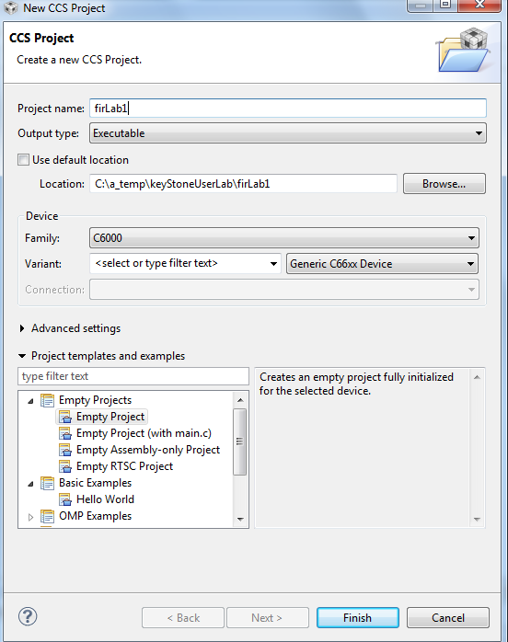

1. Then in the *Project Explorer* view, right-click on the newly-created *firLab1* project, and click on *Add Files…*
2. Browse to **C:\ti\labs\firFilter**, select all the files in this directory, and click *Open*. When prompted how files should be imported into the project, leave it as default of *Copy File.* If you defined the new project with **main.c,**remove the **main.c** file that may be created.
3. As soon as the file **firFilter.cfg** is imported into the project, CCS will ask you to enable RTSC support. See the screen shot below. Select *Yes*.

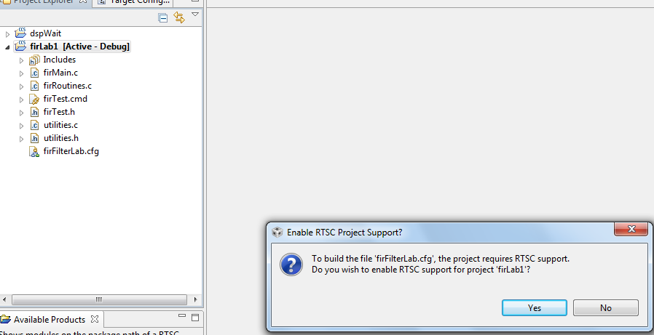

1. Open *Project Properties* and select *general*🡪*RTSC*. Look at the RTSC modules that are selected in the screen shot below and make sure that you select ONLY the same RTSC modules (or packages). When a project starts, RTSC attempts to include all the modules in the release. So unselect any module that is not selected in the screen shot.  
     
   NOTE: The TARGET CONTENT BASE should reflect the location of CCS on your system.

Figure : Select RTSC Modules

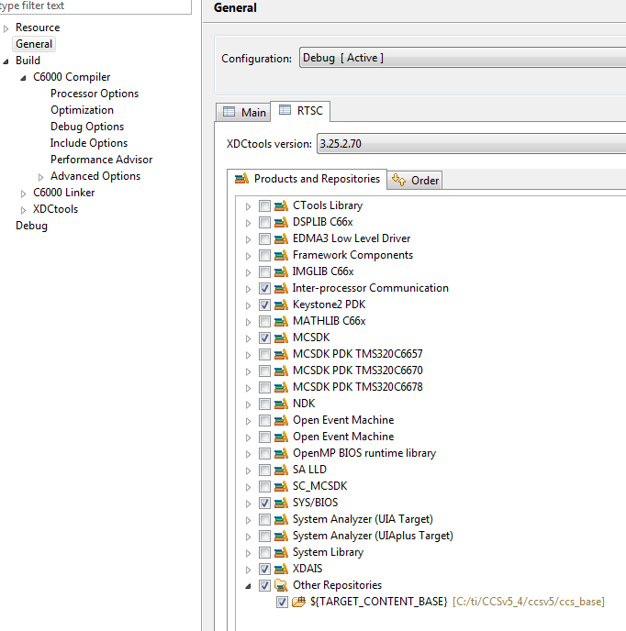

1. Click on the platform tab and select **ti.platform.evmTCI6638K2K**platform, as shown in the next screen shot.

NOTE: RTSC projects require the user to select three types of information.

* The device family in the CCS create page determines what core is used and thus what version of the compiler should be used (different cores have different intrinsic functions).
* The platform that is defined here determines the memory configuration of the core.
* To build the correct RTSC drivers, the device name should be defined. This is done by adding a predefined symbol with the device name. More about it later.

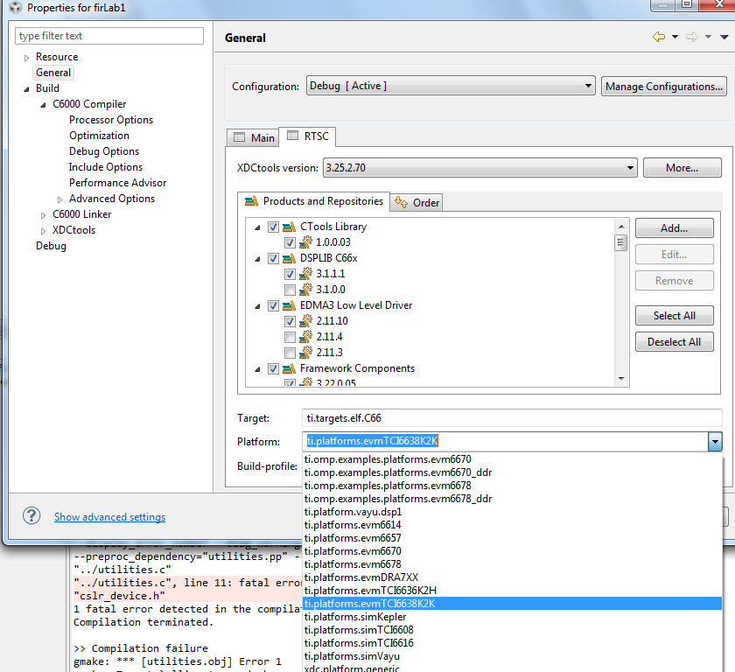

1. If you try to build the project now, you will receive a long list of errors such as the following:   
     
   C:/ti/MCSDK_3_14/pdk_keystone2_3_00_02_14/packages/ti/csl/csl_cacheAux.h", line 86: error #20: identifier "CSL_C66X_COREPAC_REG_BASE_ADDRESS_REGS" is undefined  
     
   This is because the device being used is not yet defined. So RTSC does not know how to build the drivers for the device that is used. The next step describes how to configure the device

1. Currently, the file **cslr_device.h** refers to two devices, K2K and K2H. The EVM uses the K2K device:

#if defined(DEVICE_K2K)

#include <ti/csl/device/k2k/src/cslr_device.h>

#elif defined(DEVICE_K2H)

#include <ti/csl/device/k2h/src/cslr_device.h>

#endif /* DEVICE_XXXXX */)

1. To configure the device, open the project properties, *build -> C6000 compiler ->advanced Options -> predefined symbols* and enter DEVICE_K2K as the next screen shot shows.
2. Click OK and then OK again to go to the properties page.

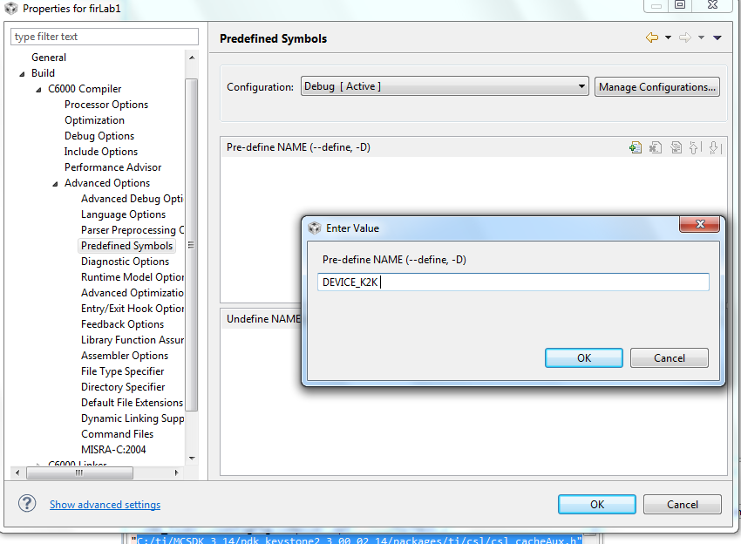

1. Right click on the project name and select *rebuild*. If the build goes correctly, you will see the following in the console window.  
     
   NOTE: Look at the debug directory to ensure that the file **firLab1.out** is there. Ignore any warnings.

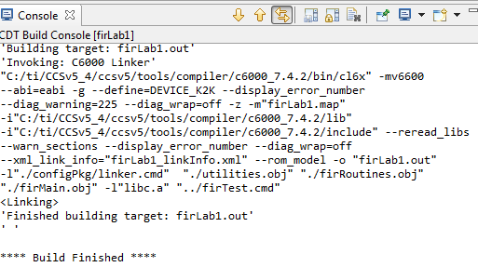

1. Examine the code in **firMain.c**. There are five cases, but only case 1 is not commented out.
   1. DSP 0 generates input data (**inputData**) and a set of filter coefficients (**filterCoef**)
   2. Depending on the case, a set of fir filters is applied to the data and the results are written to the out file (**outputFilter**).
   3. A set of timer registers (**TSCL** and **TSCH**) measure the execution time of the fir filter.
   4. The standard **printf** function prints the results on the console.

## Task 2: Define the Target

In this lab, the DSP code is run from no-boot mode. The no-boot mode requires setting the dipswitch SW1 of the EVM to: 1 Off 2 Off 3 Off 4 On.  
  
Since no-boot mode is chosen, the device configuration (DDR configuration, PLL configuration and so on) must be done in a gel file.

### Create a new target in CCS

1. Create a new target configuration:
   1. Select the CCS menu option *View 🡪 Target Configurations*.
   2. Select *User Defined*.
   3. Right-click and select *New Target Configuration*.
2. Enter the name of the new target configuration in the *File Name:* text box.
   1. Set the File name based on the EVM model, *<model>.ccxml*  
      For example, ‘TCI6638.ccxml’
   2. Leave the *Location* the default value:  
      “C:\Documents and Settings\student\ti\CCSTargetConfigurations”
   3. Click the *Finish* button. The .ccxml file will now open in a GUI-based view with the *Basic* tab active.
3. Define the new target configuration by selecting the connection type in the *Basic* Tab.
4. The *Connection* drop-down menu identifies the emulator type. For example, ‘Texas Instruments XDS2xx USB Emulator.”
   1. *Board or Device* identifies the TI processor device, set it to 6638 and select TCI6638
   2. Under *Save Configuration*, click the *Save* button.
5. Configure setup in *Advance* Tab
   1. Click the *Advanced* tab at the bottom of the screen.
   2. Select Core 0 on the target device:
      * *TCI6638_0* 🡪 *IcePick_C_0* 🡪 *Subpath_1* 🡪 *C66xx_0*
   3. You will now see a sub-window called *Cpu Properties* that allows you to choose an *initialization script*.
   4. Locate the appropriate GEL file, then click *Open*:
      * Select: **C:\ti\CCSv5_4\ccsv5\ccs_base\emulation\boards\evmtci6638k2k\gel\evmtci6638k2k.gel**
      * Repeat the process for all C66x cores, that is *C66xx_1, C66xx_2, … C66xx_7*

Click the *Save* button.

## Task 3: Connect to the EVM

1. Click the Open Perspective (available at the right top corner of the CCS window).
2. Switch to the Debug Perspective by selecting the CCS menu option *Window* 🡪 *Open Perspective* 🡪 *CCS Debug*.
3. Select the CCS menu option *View* 🡪 *Target Configurations*. Select the target configuration you created
4. Launch the target configuration as follows:
   1. Select the target configuration .ccxml file.
   2. Right click and select *Launch Selected Configuration*.
5. This will bring up the *Debug* window. NOTE: This may take some time, but you will eventually see all the device cores.
   1. Select all C66x cores (select + Ctrl)
   2. Right click and choose *group cores*.
   3. Select the group, then right click and select *Connect Target.*

## Task 4: Load and Run CASE 1

1. Select the core group and load the .out file created earlier in the lab.
   1. Select the CCS menu option *Run* 🡪 *Load* 🡪 *Load Program*
   2. Click *Browse project…*
   3. Select *firLab1.out* by unwrapping the *firLab1->Debug* and click *OK.*
   4. Click *OK* to load the application to the target (all Cores).
2. Run the application by selecting the CCS menu option *Run* 🡪 *Resume*.
3. A successful run should produce a console output as shown below. Record the cycles time:

[C66xx_0] start generating input data

finish generating input data

case 1 -> time consumed By core -> 0 610749952.000000

1. **QUESTION:**

Look at the function CACHE_disableCaching ((Uint8) 144) which disables cache-ability for memory region. What memory region is it?

See Table 4-20 in the C66 CorePac User’s Guide <http://www.ti.com/lit/ug/sprugw0c/sprugw0c.pdf>

Look at the User Guide, the code, and the map file, and fill out the table below.

|  |  |  |
| --- | --- | --- |
| **Command** | **Memory region** | **Variables in this region** |
| CACHE_disableCaching ((Uint8) 128) |  |  |
| CACHE_disableCaching ((Uint8) 136) |  |  |
| CACHE_disableCaching ((Uint8) 144 |  |  |
| CACHE_disableCaching ((Uint8) 145) |  |  |
| CACHE_disableCaching ((Uint8) 146) |  |  |
| CACHE_disableCaching ((Uint8) 147) |  |  |

## Task 5: Use Optimization and Disable Symbol Debug for the fir Filter Routine

As the project is still in development/debug state, there is no optimization and full debug support. The next step is to optimize the fir filter and disable the debug information. However, leave the other parts of the project without optimization and with full debug support. The properties for the file firRoutines.c will be changed. No other file will be effected.

1. In the project explorer, select the file **firRoutines.c** and right click. Open the properties dialogue window as shown below.
2. Select *build->optimization*. In the dialogue window set optimization to 3
3. From the debug options dialogue select *suppress all symbolic debug generation* from the pull-down menu.

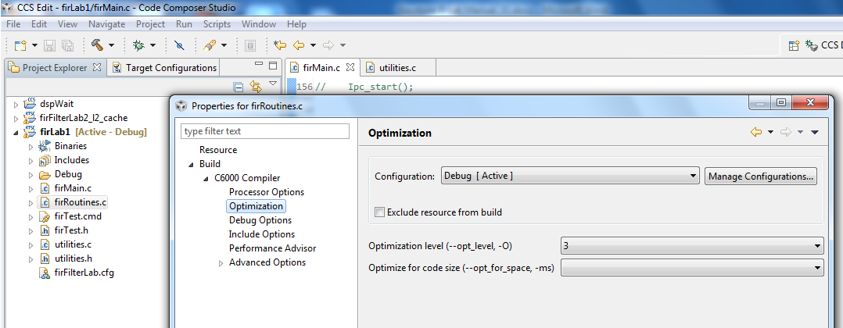

1. From the *build ->C6000 compiler -> Advanced Debug,* select *Assembly options* and check *Keep the generated assembly language (.asm)* file as shown in the screen shot below.

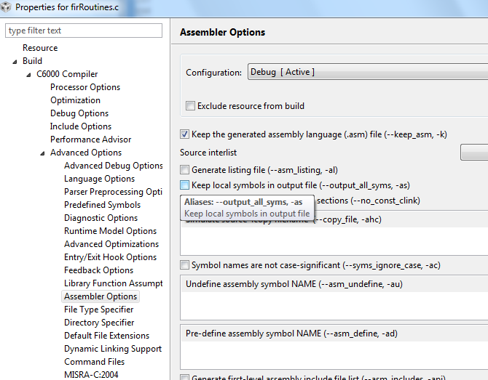

1. Click OK and rebuild the project. Load and run.
2. A successful run should produce a console output as shown below. Record the cycles time:

**Start generating input data**

**Finish generating input data**

**Case 1: Time consumed by core -> 0 500579008.000000**

1. **QUESTION:**

Is the code really optimized? Only 15% improvement.

Look at the assembly file firRoutines.asm in the debug directory and search for the function firRealFilter. Look for the loop and see if the compiler could get software pipeline

What is the reason that the loop does not qualify for software pipeline?

## Task 6: Optimize Software Pipeline

The reason why the fir filter loop is not qualified for a software pipeline is because it calls myMultiply. The next task is to inline this function. myMultiply is an artificial function (i.e., no one will develop this function in real code). So it is easy to “inline” it. Look at the definition of myMultiply in the utilities.c file and inline it.

1. Change the function firRealFilter by inline myMultiply function
2. Save and build the project. Load and run.
3. A successful run should produce a cosole output as shown below. Record the cycle time:

**start generating input data**

**finish generating input data**

**case 1 -> time consumed By core -> 0 273086080.000000**

1. Next, tell the compiler the minimum number times that each loop will be executed. The filter size in this program is 8. Assume that the filter size will always be more than 4 and divided by 4, so adding a pragma( **#pragma** MUST_ITERATE(4,,4); ) will tell the compiler that the inner loop must be performed at least 4 times and the number of iterations is divided by 4.
2. The outer loop presents the size of the output vector. The number of elements is 16K, but eventually we would like to run it on all 8 cores, so each core will have about 2K element. It is enough if we tell the compiler that the number of elements is more than, say 64. However, if you look carefully, you will notice that the number of output results is 16K – filter size + 1, so this is an odd number. You can tell the compiler that the number of elements is more than 64. In that case use something like (**#pragma** MUST_ITERATE(64,,1); ) or, if you agree to ignore the last fake result, you can tell the compiler (**#pragma** MUST_ITERATE(4,,2); ))
3. Add the two pragma directives before the two loops (internal and external) in the function save and build.
4. If the external loop is **pragma** MUST_ITERATE(64,,1)

**start generating input data**

**finish generating input data**

**case 1 -> time consumed By core -> 0 221407008.000000**

1. If the external loop is **pragma** MUST_ITERATE(64,,2);

**start generating input data**

**finish generating input data**

**case 1 -> time consumed By core -> 0 221306848.000000**

1. **QUESTION:** To summarize the code optimization section, complete the following table:

|  |  |  |
| --- | --- | --- |
| **Optimization Technique** | **Cycles** | **Improvements compared with previous line** |
| No Optimization |  |  |
| Compiler optimization 3, no symbolic debug |  |  |
| Software Pipeline |  |  |
| Adding pragma must iterate |  |  |

## Task 7: Enable the Cache

Enabling the cache is done in CASE 2. Un-comment the line **#define CASE_2** above the **main()** in **firMain.c**

1. **QUESTION:**

What instruction(s) enable the cache?

The function CACHE_enableCaching ((Uint8) 128) ; was discussed in Task 4. The function CACHE_setL2Size ((CACHE_L2Size) 4); is part of the file csl_cachAux.h in the \MCSDK_3_14\pdk_keystone2_3_00_02_14\packages\ti\csl directory. Note, version number and location of MCSDK may be different for your setting.

1. Un-comment the line **#define CASE_2** in **firMain.c**
2. Save, build, load and run. The results will look like the following:

**start generating input data**

**finish generating input data**

**case 1 -> time consumed By core -> 0 221223008.000000**

**case 2 -> time consumed By core -> 0 7491409.000000**

1. **QUESTION: Complete the table.**

|  |  |  |
| --- | --- | --- |
| **Optimization Technique** | **Cycles** | **Improvements compare with previous line** |
| No Optimization |  |  |
| Compiler optimization 3, no symbolic debug |  |  |
| Software Pipeline |  |  |
| Adding pragma must iterate |  |  |
| Enabling cache |  |  |

1. **QUESTION: What are the most important steps to optimize code running on a single core?**

## Task 8: Running in Parallel on Multiple Cores

Multiple cores are enabled in CASE 3 (2 cores), CASE 4 (4 cores) and CASE 5 (8 cores).

Un-comment the lines **#define CASE_3 #define, CASE_4** and **#define CASE_5** above the **main()** in **firMain.c**

2. Un-comment the line #define CASE_3 #define CASE_4 #define CASE_5 in firMain.c
3. Save, build, load and run. The results will be look like the following:

**finish generating input data**

**case 1 -> time consumed By core -> 0 288423616.000000**

**case 2 -> time consumed By core -> 0 7493824.000000**

**case 3 -> time consumed By core -> 0 3680093.000000**

**[C66xx_1] case 3 -> time consumed By core -> 1 3678251.000000**

**[C66xx_0] case 4 -> time consumed By core -> 0 1839643.000000**

**[C66xx_1] case 4 -> time consumed By core -> 1 1838608.000000**

**[C66xx_2] case 4 -> time consumed By core -> 2 1839438.000000**

**[C66xx_3] case 4 -> time consumed By core -> 3 1836440.000000**

**[C66xx_0] case 5 -> time consumed By core -> 0 918711.000000**

**[C66xx_1] case 5 -> time consumed By core -> 1 921884.000000**

**[C66xx_2] case 5 -> time consumed By core -> 2 921973.000000**

**[C66xx_3] case 5 -> time consumed By core -> 3 920785.000000**

**[C66xx_6] case 5 -> time consumed By core -> 6 922374.000000**

**[C66xx_4] case 5 -> time consumed By core -> 4 923078.000000**

**[C66xx_5] case 5 -> time consumed By core -> 5 921646.000000**

**[C66xx_7] case 5 -> time consumed By core -> 7 920075.000000**

For each case, the total time that is consumed to perform the FIR filter is the maximum time of all the cores.

**QUESTION: Complete the table**

|  |  |  |  |  |
| --- | --- | --- | --- | --- |
| **Case** | **Cycles per core** | **Execution cycles (this is the cycles of the core with the highest cycles count)** | **Accumulate execution time for all the cores** | **Penalty of the accumulation execution time compared to single core (CASE 2)** |
| Case 2 – single core |  |  |  |  |
| Case 3 – 2 cores |  |  |  |  |
|  |
| Case 4 – 4 cores |  |  |  |  |
|  |
|  |
|  |
| Case 5 – 8 cores |  |  |  |  |
|  |
|  |
|  |
|  |
|  |
|  |
|  |

**QUESTIONS:**

1. What is the purpose of the function **waitBarrier(barrier_1, coreNum, jointNumber)**? What would happen if the function is commented out?

Try to comment out the function (3 places) and see what happens.

1. What is the purpose of the function **waitAboutNSeconds(10)** inside the function **waitBarrie**? What would happen if the function is commented out? Do you understand why?

Try to comment out the function and see what happens. Think about timing between cores.

1. Can you think about other (better) methods to synchronize the execution of all the cores?

Semaphores?, QMSS queues based solution?, openMP? .

# Lab 6: Load and Run DSP Code Using MPM Server

In this lab, you build a DSP project similar to the previous lab. Before starting, you should change the boot mode of the EVM to no-boot mode. Set SW1 of the EVM back to 1 Off 2 Off 3 On 4 Off.

Read the instructions in Lab 3 to ensure that the EVM boots using NFS-mounted file system.

## Purpose

Building a DSP code that is managed by the ARM. The ARM will reset C66x Core 0, load it with an executable, run it, and retrieve the results.

## Project Files

The following files are used in this lab:

* Main.c
* mpmsrv_keystone2_example1.cfg

## Task 1: Build and Run the Project

1. ftp into the Ubuntu server and get all the files that are in directory **/usr/local/projects/DSP/mpm** into a local directory **c:\ti\labs\mpm_example** on your PC. If this directory does not exist, create it.
2. Open CCS.
3. Create new project through the CCS menu item *File* 🡪 *New* 🡪 *CCS Project*.
4. Enter *mpm_example* as a *Project Name*.
5. Click the check box to *Use default location.*
6. Set the *Family to C6000* and *Variant* to *Generic C66xxx Device*
7. Then press *Finish* to create the new project
8. Then in the *Project Explorer* view, right-click on the newly-created *mpm_example* project, and click on *Add Files…*
9. Browse to **C:\ti\labs\mpm_example**, select all the files in this directory, and click *Open*. When prompted how files should be imported into the project, leave it as default of *Copy File.* If you defined the new project with **main.c**,remove the **main.c** file that may be created.
10. As soon as the file **mpmsrv_keystone2_example1.cfg** imported into the project, CCS will ask you to enable RTSC support, Select yes.
11. Open Project Properties and select general->RTSC. Look at the RTSC modules that are selected in the screen shot below and make sure that you select ONLY the same RTSC modules (or packages). When a project starts, RTSC attempts to include all the modules in the release. So unselect any module that is not in the screen shot.  
      
    NOTE: The TARGET CONTENT BASE should reflect the location of CCS on your system.

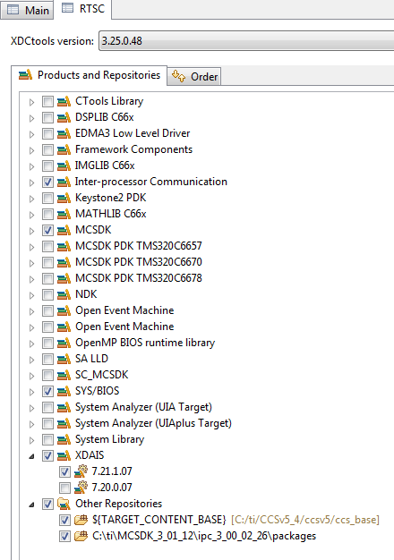

1. Click on the platform tab and select **ti.platform.evmTCI6638K2K**platform

NOTE: RTSC projects require the user to select three types of information.

* The device family in the CCS create page determines what core is used and thus what version of the compiler should be used (different cores have different intrinsic functions).
* The platform that is defined here determines the memory configuration of the core.
* To build the correct RTSC drivers, the device name should be defined. This is done by adding a predefined symbol with the device name. More about it later.

1. Right click on the project name and select *rebuild*. If the build goes correctly, you will see the following in the console window. NOTE: Look at the debug directory to ensure that the file **MPM_example.out** is there. Ignore any warnings.

**'Building target: MPM_example.out'**

**'Invoking: C6000 Linker'**

**"C:/ti/CCSv5_4/ccsv5/tools/compiler/c6000_7.4.2/bin/cl6x" -mv6600 --abi=eabi -g --display_error_number --diag_warning=225 --diag_wrap=off -z -m"MPM_example.map" -i"C:/ti/CCSv5_4/ccsv5/tools/compiler/c6000_7.4.2/lib" -i"C:/ti/CCSv5_4/ccsv5/tools/compiler/c6000_7.4.2/include" --reread_libs --warn_sections --display_error_number --diag_wrap=off --xml_link_info="MPM_example_linkInfo.xml" --rom_model -o "MPM_example.out" -l"./configPkg/linker.cmd" "./main.obj" -l"libc.a"**

**<Linking>**

**'Finished building target: MPM_example.out'**

**' '**

**\*\*\*\* Build Finished \*\*\*\***

## Task 2: Using MPM to load, run and observe results

In this part, we assume that the EVM is boot in net mode, that is, the file system is on the server and it is mounted to the EVM as used in Lab3

1. FTP the out file into the server to **/opt/filesys/studentN/bin** where N is the student number.
2. Reboot the EVM using NFS.
3. From the terminal login as **root**
4. **cd /bin**
5. Use MPM to reset, load, and run core 0 with **MPM_example.out** by using the following MPM commands:

**mpmcl reset dsp0**

**mpmcl load dsp0 MPM_example.out**

**mpmcl run dsp0**

1. After the end of run look at the trace buffer printing by using the following command

**cat /debug/remoteproc/remoteproc0/trace0**

1. Change the main.c file as you wish, build it again, ftp to the file system (step 7) load the code to a different dsp (use N here) and run it:

**mpmcl reset dspN**

**mpmcl load dspN MPM_example.out**

**mpmcl run dspN**

1. After the end of run look at the trace buffer printing by using the following command:

**cat /debug/remoteproc/remoteprocN/trace0**

# 

# Lab 7: ARM-DSP Communication Using MPM & Shared DDR

In this lab, you build a DSP project similar to Lab 4 that uses the DDR. Unlike the previous Lab where the code and the data were only in L2, in this lab some DDR is used by the DSP.

## Purpose

Building a DSP code that uses the DDR and is managed by the ARM.

## Linux and DSP simple memory management

The previous project uses private L2 memory for program and data. This DSP project uses DDR. How does the system manage the DDR resources between the DSP and the ARM?

The Linux uses part of the DD. So if a DSP program uses some of the DDR, it must tell the Linux. This is done in the U-BOOT environment.

To do it correctly, the user must follow the following steps:

1. Stop autoboot and look at the messages from the U-BOOT. It looks like the following:

**I2C: ready**

**Detected SO-DIMM []**

**DRAM: 1 GiB**

**NAND: 512 MiB**

**Net: TCI6638_EMAC, TCI6638_EMAC1**

**Hit any key to stop autoboot: 0**

The size of the DRAM is 1 GiB in this case. It can be 2G or 8 G depends on the EVM revision

1. Now determine how much DRAM the DSP needs. Obviously it must be less than the total DRAM in the EVM. Assume that Linux uses 512M and the DSP will use 512M. The user must tell the U-BOOT that 512M is reserved for the DSP.
2. After stopping the autoboot, configure the memory that is assigned to the DSP (if it is not configured already).

**setenv mem_reserve 512M** (For EVM with 2G DRAM it can be 1536M  
 or even larger if the DRAM is more than 2G)

**saveenv and boot**

1. The memory that is reserved for the DSP is located at the end of the available memory. For the 1G DRAM case, available memory is between 0x80000000 and 0xbfffffff, so the 512M reserved for the DSP start at address 0xa0000000 to address 0xbfffffff
2. Next, you need to build the DSP code and ensure that it uses only the assigned DDR. One way to do this when using RTSC is to re-define the platform. The release platform defines DDR starting at 0x80000000 and with size 0x80000000.
3. To modify the platform in CCS, go to the debug perspective *tools -> RTSC Tools ->platform -> edit/view*. Make sure that the repository is the location of XDCTools/packages (in MCSDK_3_14 setting it is in *“MCSDK_3_14\xdctools_3_25_02_70\packages”* and click on package name. Choose the package that corresponds to the EVM, (the current EVM is *ti.platforms.evmtci6638K2K*), CPU core is CPU, and click NEXT.

Changing the platform as illustrated in the following screen shot.

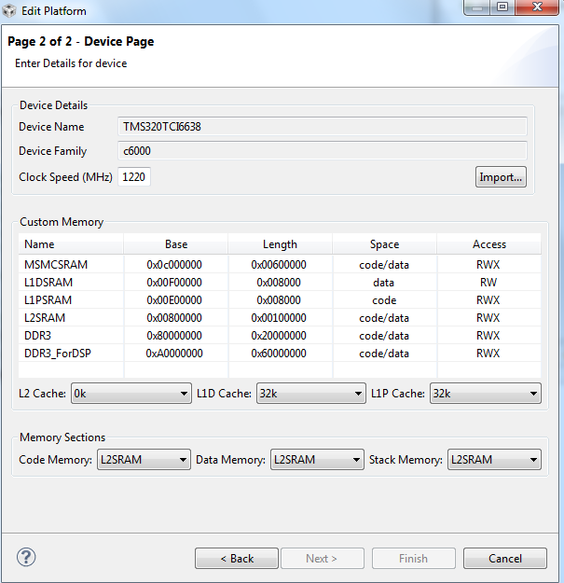

1. In a link command file XXX.cmd, make sure that all DDR sections are assigned to the memory DDR3_ForDSP (in the case above). Verify the correct address in the map file after rebuilding the project.
2. As was mentioned before, the DSP in this lab does not use the DDR. So for this lab, the above procedure is not necessary. However, it can be used as reference for more complex projects.

## Project Files

The following files are used in this lab:

* Main.c
* mpmsrv_keystone2_example1.cfg

## Build and Run the Project

1. FTP into the Ubuntu server and get all the files that are in directory /usr/local/projects/DSP/mpm into a local directory on your Laptop c;\ti\labs\mpm_example. If this directory does not exist, create it
2. Open CCS.
3. Create new project through the CCS menu item *File* 🡪 *New* 🡪 *CCS Project*.
4. Enter *mpm_example* as a *Project Name*.
5. Click the check box to *Use default location.*
6. Set the *Family to C6000* and *Variant* to *Generic C66xxx Device*
7. Then press *Finish* to create the new project
8. Then in the *Project Explorer* view, right-click on the newly-created *mpm_example* project, and click on *Add Files…*
9. Browse to ‘C:\ti\labs\mpm_example,’ select all the files in this directory, and click *Open*. When prompted how files should be imported into the project, leave it as default of *Copy File.* If you defined the new project with main.cremove the main.c file that may be created.
10. As soon as the file mpmsrv_keystone2_example1.cfg imported into the project, CCS will ask you to enable RTSC support, Select yes.
11. Open Project Properties and select general->RTSC. Look at the RTSC modules that are selected in the screen shot below and make sure that you select ONLY the same RTSC modules (or packages). When a project starts, RTSC attempts to include all the modules in the release. So unselect any module that is not in the screen shot.  
      
    NOTE: The TARGET CONTENT BASE should reflect the location of CCS on your system.



1. Click on the platform tab and select ***ti.platform.evmTCI6638K2K*** platform

NOTE: RTSC projects require the user to select three types of information.

* The device family in the CCS create page determines what core is used and thus what version of the compiler should be used (different cores have different intrinsic functions).
* The platform that is defined here determines the memory configuration of the core.
* To build the correct RTSC drivers, the device name should be defined. This is done by adding a predefined symbol with the device name. More about it later.

1. Right click on the project name and select *rebuild*. If the build goes correctly, you will see the following in the console window.  
     
   NOTE: Look at the debug directory to ensure that the file **firLab1.out** is there. Ignore any warnings.

**'Building target: MPM_example.out'**

**'Invoking: C6000 Linker'**

**"C:/ti/CCSv5_4/ccsv5/tools/compiler/c6000_7.4.2/bin/cl6x" -mv6600 --abi=eabi -g --display_error_number --diag_warning=225 --diag_wrap=off -z -m"MPM_example.map" -i"C:/ti/CCSv5_4/ccsv5/tools/compiler/c6000_7.4.2/lib" -i"C:/ti/CCSv5_4/ccsv5/tools/compiler/c6000_7.4.2/include" --reread_libs --warn_sections --display_error_number --diag_wrap=off --xml_link_info="MPM_example_linkInfo.xml" --rom_model -o "MPM_example.out" -l"./configPkg/linker.cmd" "./main.obj" -l"libc.a"**

**<Linking>**

**'Finished building target: MPM_example.out'**

**' '**

**\*\*\*\* Build Finished \*\*\*\***

# Lab 8: Build and Run ARM Code Using CCS on Linux

## Purpose

The goal of this lab is to demonstrate some basic operations using CCS on ARM code as preparation for EVM debug from CCS.

## Prerequisites

CCS must be installed on the Linux machine.

## Task 1: CCS - Start a new cross compiler project and build it

1. To start CCS, go to CCS eclipse directory and enter the following:

**sudo ./ccstudio**

1. After CCS start, and in the edit perspective, start a new (not CCS) project:

*File -> New -> Project* (Not CCS Project)

*C/C++* and then *C project*

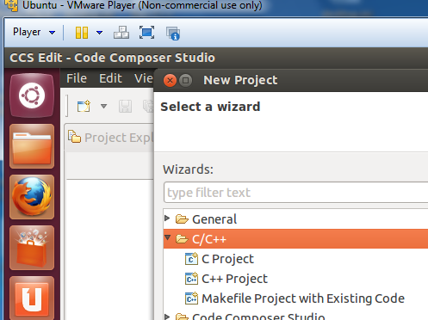

1. From the C project, choose Hello World ANCI C project, Toolchains Linux GCC, give the project a name (myHello), and finish.

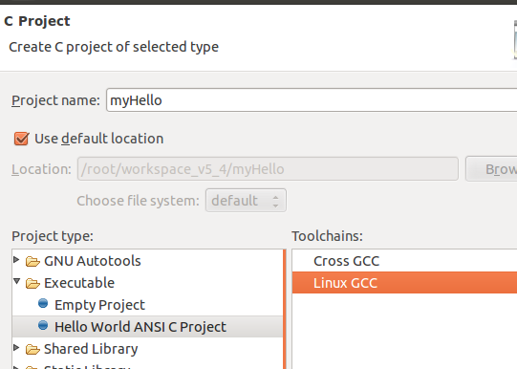

1. Before continuing, to make the Lab a little more interesting, you can change the source code using CCS editor. The following is a version of myHello.

**int** **main**(**void**)

{

**int** i, j, k, l ;

**printf**("printf command start the program \n") ;

**puts** (" puts command start the program \n") ;

l = 12 ;

**for** (i=0; i<1000; i++)

{

j = l + i ;

k = 2 * j ;

l = k + j ;

**if** (l > 10000)

{

**printf**(" inside loop, l > 10000 i= %d k = %d j = %d l = %d \n", i,k,j,l) ;

l = l - 10000 ;

**printf**(" after the normalization i= %d k = %d j = %d l = %d \n", i,k,j,l) ;

}

}

**printf**(" END ->>> i= %d k = %d j = %d l = %d \n", i,k,j,l) ;

**puts**("!!!Hello World!!!"); /* prints !!!Hello World!!! */

**return** 1;

}

1. Next configure the project properties. Right click on the project and start properties. Open C/C++ build and open settings. In the dialogue window select GCC C compiler and enter arm-linux-gnueabihf-gcc. The same tool will be set for the linker as well.

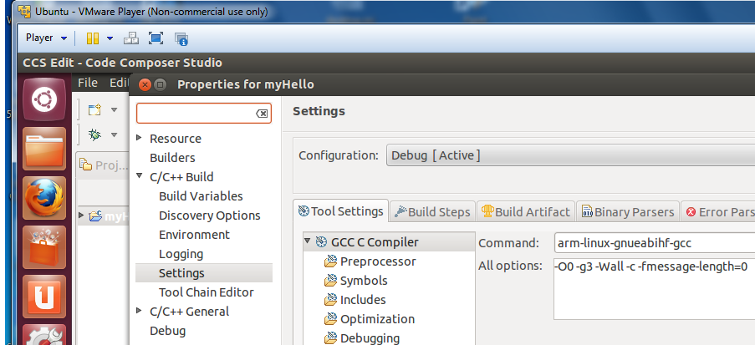

For assembly, choose the arm-linux-gnueabihf-as assembler.

Next the include path to the tools should be configured. From project properties select

C/C++ General->Path and Symbols

Note: Depending on project requirements, more paths may be needed  
  
 From ***Includes*** tab Add GNU C Includes. The easier way is by going to ADD and then file system and browse:  
 DirectoryWhereTheToolsAre/gcc-linaro-arm-linux-gnueabihf-4.7-2013.03-20130313_linux/arm-linux-gnueabihf/libc/usr/include  
 DirectoryWhereTheToolsAre /gcc-linaro-arm-linux-gnueabihf-4.7-2013.03-20130313_linux/arm-linux-gnueabihf/libc/usr/include/arm-linux-gnueabihf  
 - ***Add to all configurations***

From ***Library Paths*** tab Add Library Paths

DirectoryWhereTheToolsAre /gcc-linaro-arm-linux-gnueabihf-4.7-2013.03-20130313_linux/arm-linux-gnueabihf/libc/usr/lib/arm-linux-gnueabihf  
 - ***Add to all configurations***

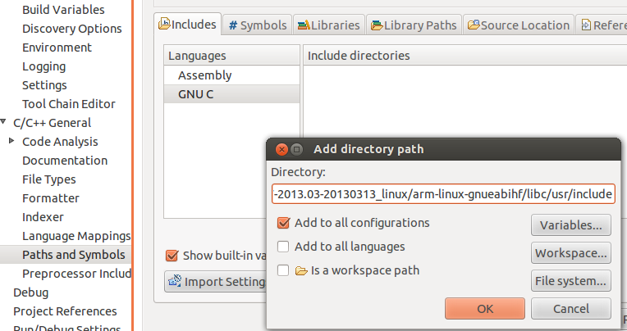

Last the path to the tools should be configured. From project properties select

1. Right-click Project, select ***Properties***
2. Select ***C/C++ Build***🡪***Environment***
3. Click Add…

Enter Name: **PATH**, ***Add to all configurations***

Press ***OK***  (ccs will automatically populate with internal path)

1. Select **PATH**, click ***Edit…***
2. Prefix string with path to toolchain binaries  
    (e.g. /opt/gcc-linaro-arm-linux-gnueabihf-4.7-2013.03-20130313_linux/bin)
3. Path must be delimited with a colon ‘:’

Do clean build and build

The consol should look like the following:

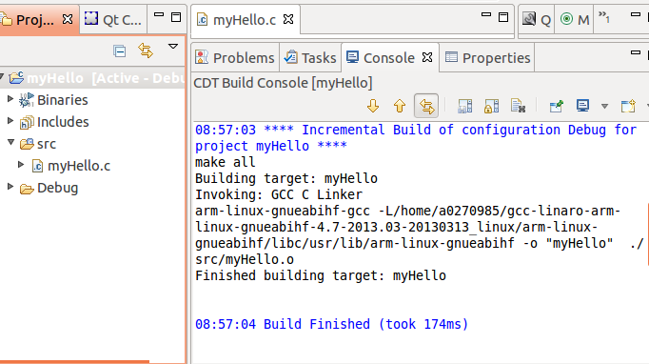

## Task 2: GDB from the tera-terminal

There are multiple ways to use gdb to run and debug myHello. It can be done outside of CCS or within CCS.

### Move the Debug directory outside of CCS

* First allocate where the program is located in the linux host system. From property -> resources you will see something like:

**/root/workspace_v5_4/myHello**

Where workspace_v5_4 is the default workspace for CCS.

* An alternative method is to search for the myHello project:

cd / takes us to the start of file system

**sudo find . –name myHello –print** (look for all files with the name myHello in them)

* Go to the myHello directory and change the permissions on the Debug sub-directory

**sudo chmod 777 Debug**

* move the Debug directory to the EVM file system (if the default setting was used, it is in /opt/filesys)

**cd /opt/filesys**

**cd bin**

**sudo cp –R /root/workspace_v5_4/myHello/Debug .**

* From the tera-terminal go to the bin subdirectory and look at the Debug subdirectory. The src sun-directory should have the source code.
* Start the gdb from the tera-terminal

**gdb myHello**

**display the source code**

**list**

* Put a breakpoint after the printf

**b 17**

* run the code and observe the printing on the terminal

r

c

You can play with other gdb instructions.

## Task 3: Connect a SSH terminal into the target

1. After reboot and login the target from the tera-terminal, do ifconfig eth0 and see what the IP address of the target is. Note, the IP address is assigned by the DHCP server.
2. Start CCS; Select ***Window🡪Open Perspective🡪Other***  
   Open Perspective: Check ***Show All***, Select ***Remote System Explorer***  
   Allow enablement of “Remote System Explorer Tools”

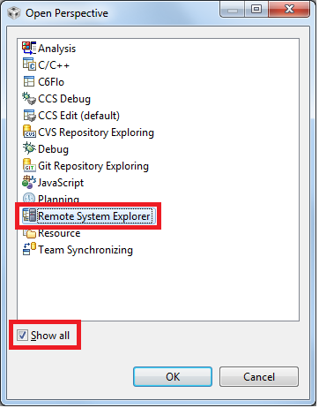

1. Select ***CCS Edit*** perspective



1. Select ***Window🡪Show View🡪Other***  
   Expand Remote Systems, Select ***Remote Systems***  
   Optionally drag Remote Systems to different location  
   (next to Project Explorer tab is a nice spot…)

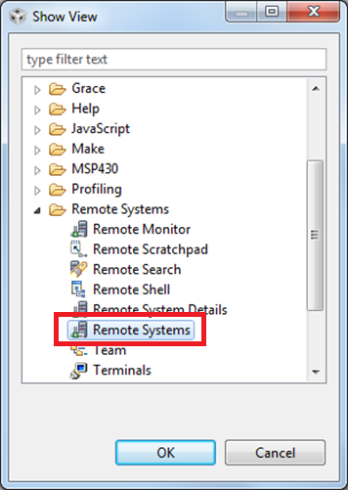

1. From Remote Systems window, Right-Click🡪***New🡪Connection…*** in the window, select linux and click next

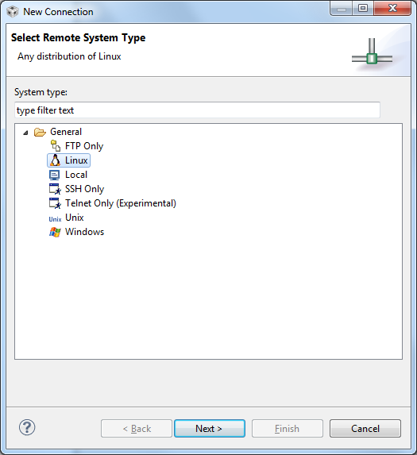

1. Configure the remote linux connection, enter the IP address as the host name, give connection name and profile name:

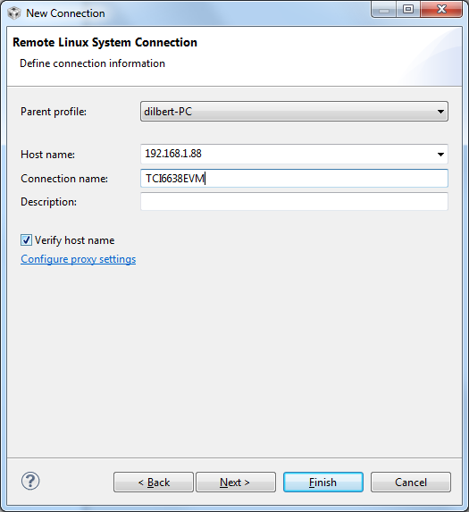

1. Files, select ssh.files

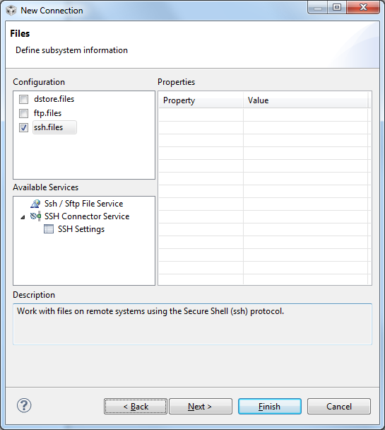

1. Click Next
2. Select processes.shell.linux

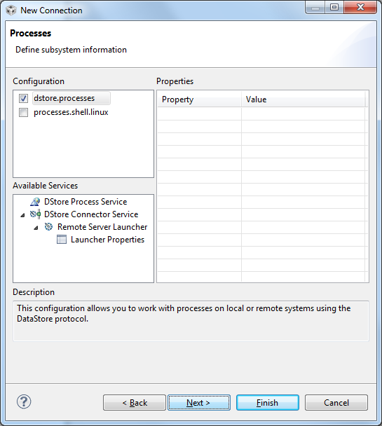

1. Click Next
2. Select ssh.shells
3. Click Next

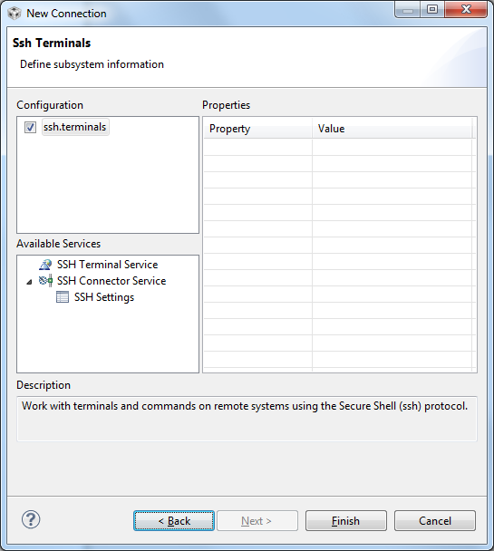

1. Select ssh.terminals
2. Finish
3. Opening a terminal:  
    Right-Click, Select ***Launch Terminal***  
    Enter password (for root user name leave the password blank)

After warnings a terminal will be opened into the target ARM

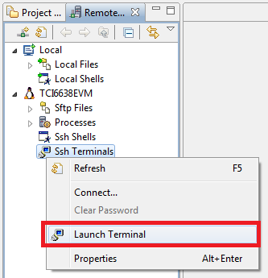

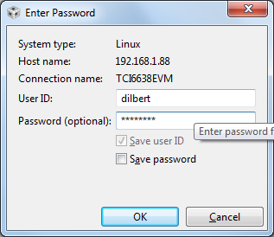

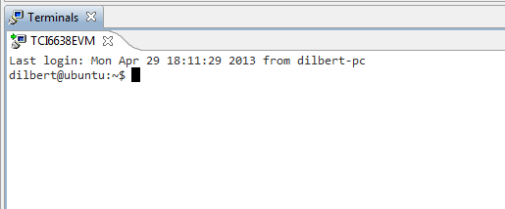

Note – the green arrow indicates that the connection is good. If there is not green arrow, and a proxy server is involved, there may be an additional step required to configure the proxy. Instructions how to configure the proxy are at the end of the Lab. (Task 5)

1. Copy and paste binaries onto the target

Select binary file and the source file from project  
Press ***Ctrl-C*** (or right-click, Copy)  
 Click on ***Remote Systems*** tab  
Navigate through the ftp Files tree to desired path  
Press ***Ctrl-V*** (or right-click, Paste)

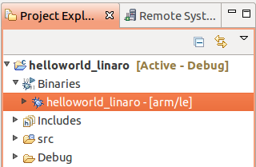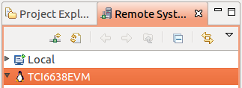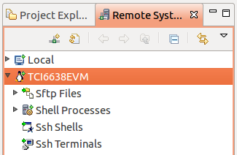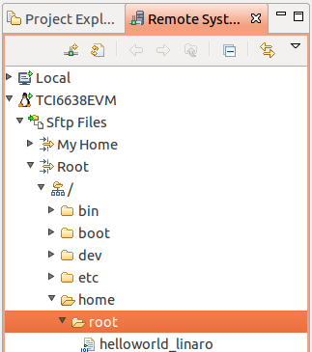

1. Executing binary on target from CCS RSE Terminal window

1. From the ***Remote Systems*** tab, right-click ***Ssh Terminals***  
 Select ***Launch Terminal***  
2. For newly transferred files, give them executable  
 permissions:  
 chmod 777 ./myHello  
  
3. Execute application  
 ./myHello

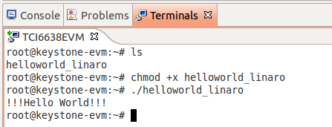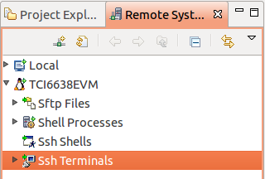

## Task 4: Optional – Use gdb to debug the application

In the edit prospective, select the project myHello

Select ***Run***🡪***Debug configurations*** from file menu

Select ***C/C++ Remote Application***

Click ***New*** button

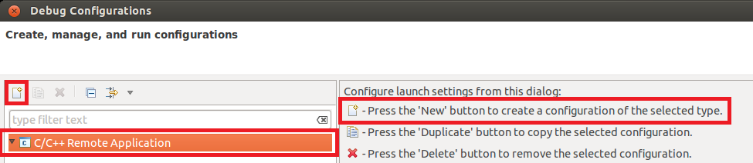

Main tab:

* + Connection: select EVM [this is configured in WS1]
  + Specify Remote Absolute File Path for C/C++ Application (for example /bin/myHello if you pasted myHello in the bin directory)

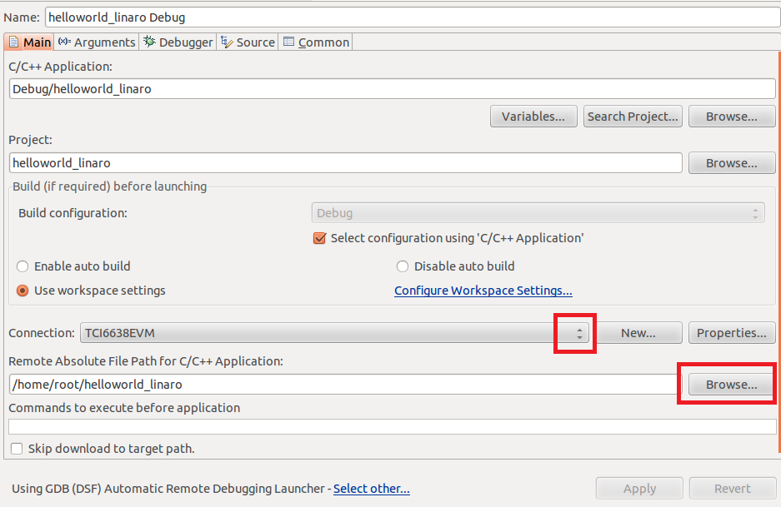

. ***Debugger*** tab:

***Main*** sub-tab:

* + GDB debugger🡪***Browse…***:  
     opt/gcc-linaro-arm-linux-gnueabihf-4.7-2013.03-20130313_linux/bin/arm-linux-gnueabihf-gdb

***Shared Libraries*** sub-tab:

* + ***Add…***  
    opt/gcc-linaro-arm-linux-gnueabihf-4.7-2013.03-20130313_linux/arm-linux-gnueabihf/libc/lib/arm-linux-gnueabihf

Press ***Apply***, ***Debug***

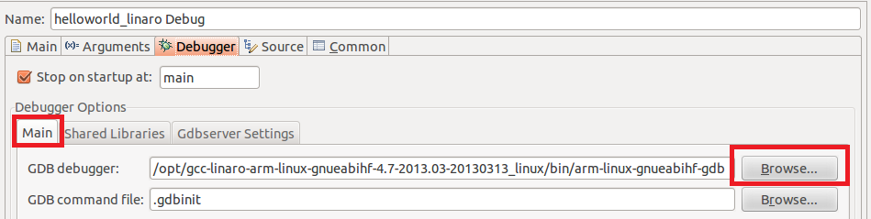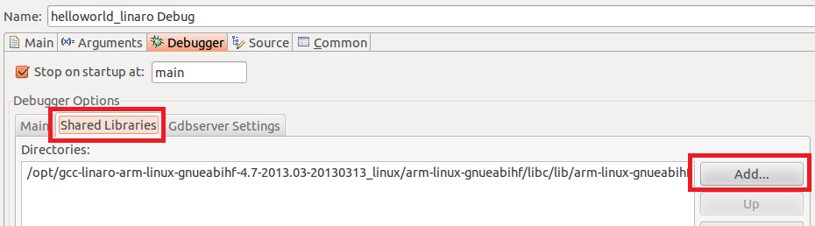

Using the debug in the debug prospective:

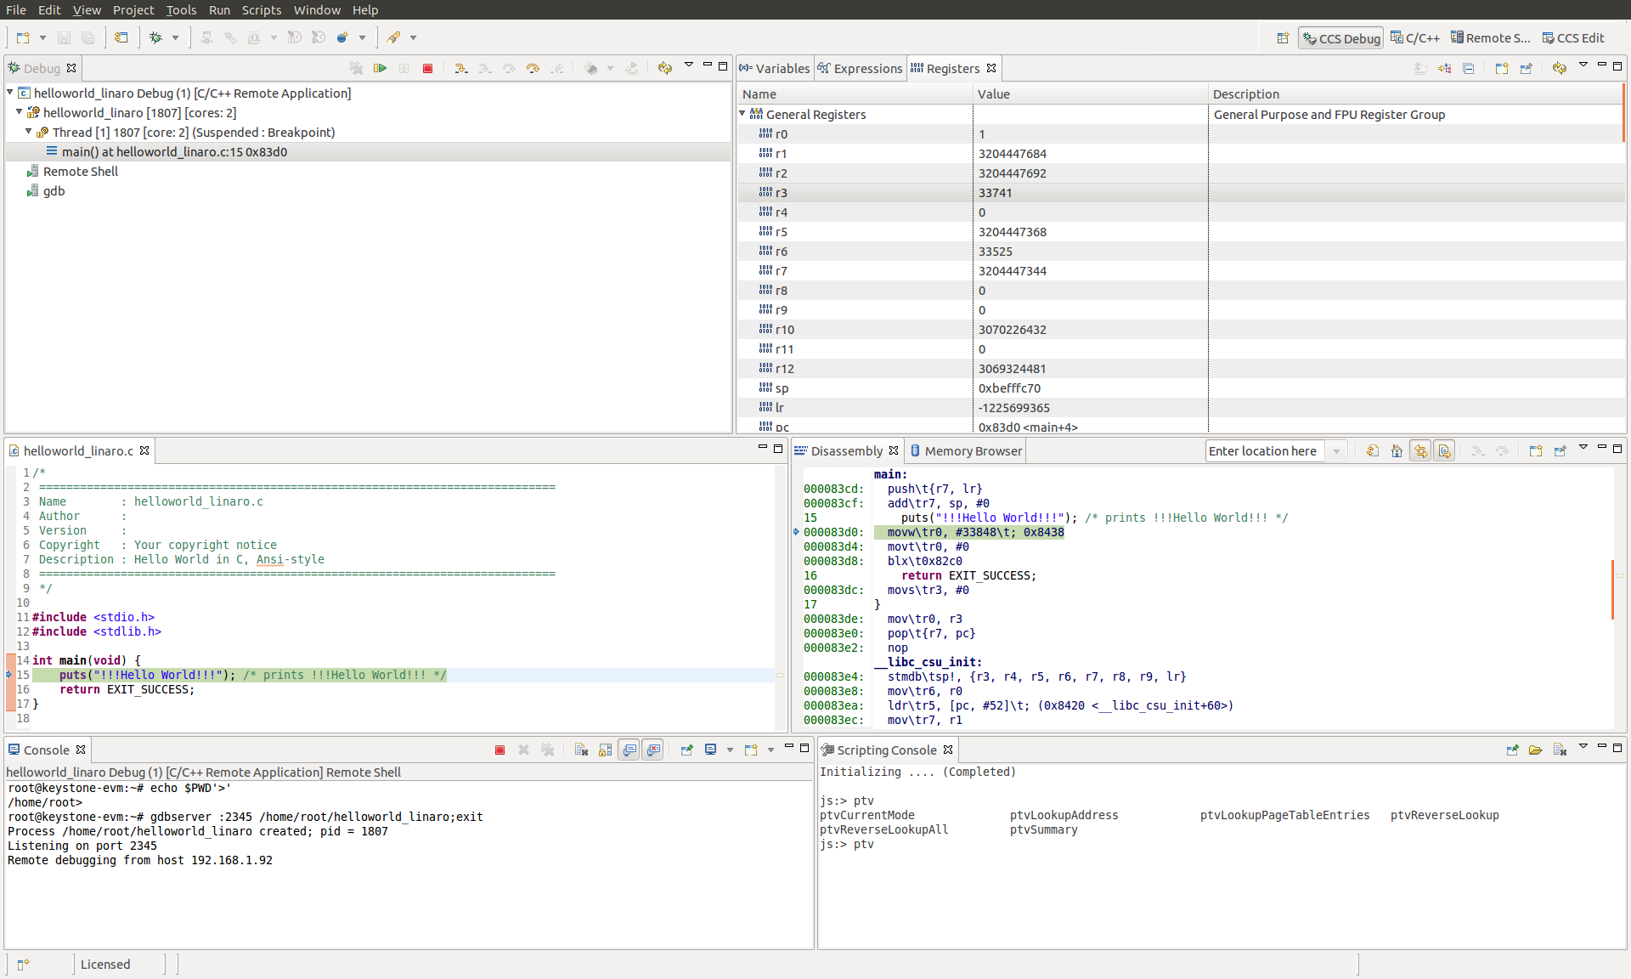

Using the debugger – one step into program:

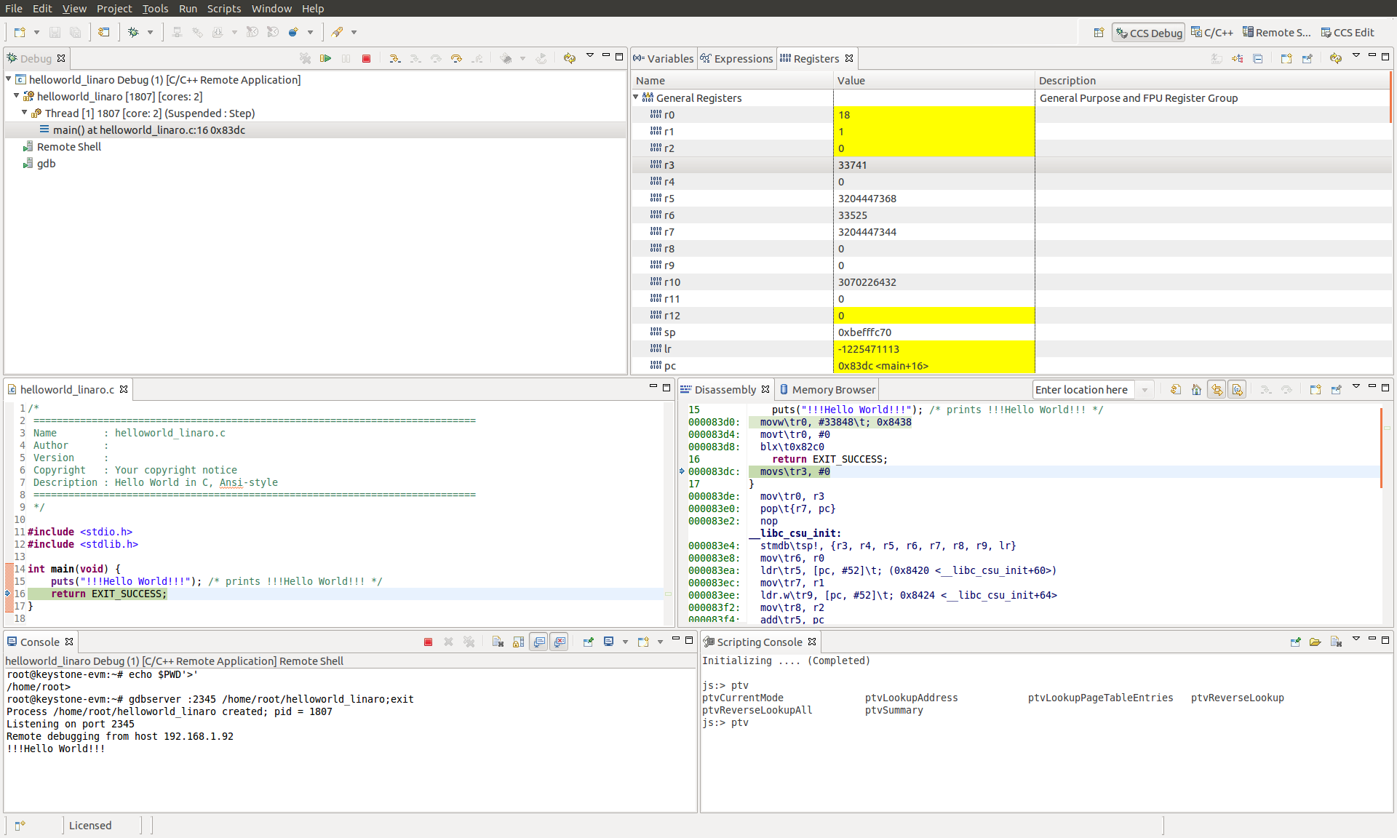

Using the debugger – gdb console

Selecting gdb from the Debug panel allows direct control of gdb

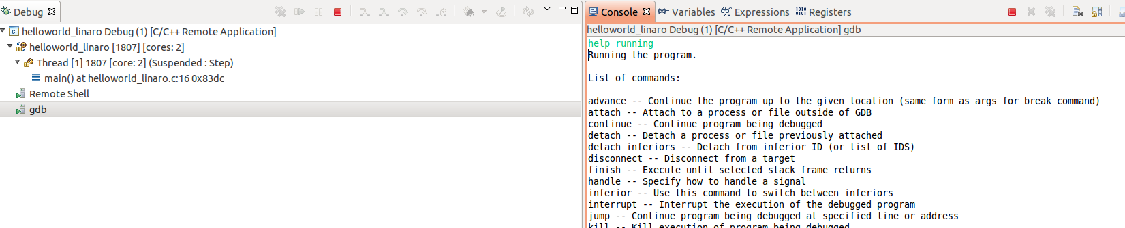

Select the gdb and from the consol you can use almost all gdb commands, breakpoint, continue and so on.

Note – I was unable to move the pc backwards, or do reset or reload. If I want to go backwards I had to close the remote debug terminal and open it again. Obviously the r (run) command does not work (run can start execution from the beginning of the execution)

## Task 5: Configure the host proxy

CCS defaults to using the system proxy settings (should not be needed if the target and the host are on the same subnet).

Right-click on the connection, select ***Properties***

From the left pane, select ***Host.*** Click ***Configure proxy settings***

From ***Network Connections,*** set ***Active Provider*** to ***Direct,*** click ***Apply*** and ***OK***

# Lab 9: ARM Optimization Using SMP Linux

## Projects and source code

Unless instructed by the instructor otherwise, all projects and source code are available on the server. Directory /usr/local/projects has two sub-directories, ARM and DSP. The source for this ARM sub-directory is in the ARM subdirectory in a subdirectory called SMP.

## Purpose

The purpose of this lab is to demonstrate how the SMP LINUX distributes threads between multiple cores and as a result speed up the processing of time sensitive application running on the 4 A15 of KeyStone II.

The default application is a typical signal processing fir filter algorithm. Fir filters can be easily partition between multiple threads. The program was structured such that it is very easy to replace the fir filter with any generic easy to partition application.

## Task 1: Copy and observe the source files

It is assumed that the file system is mounted to the EVM (NFS boot, setenv boot net) and that the file system is in location /opt/filesys/studentN where N is the student number.

From the VNC window log-in as your student name (user name studentN, password WsN where N is the student number) and run the initialization script file

* Source /usr/local/staudentStartScript.sh

In the studentN file system location make a new directory (if it does not exist already) and name it applications and then make a subdirectory smp_test

* cd /opt/filesys/studentN
* sudo mkdir applications
* cd applications
* sudo mkdir smp_test
* cd smp_test

Note – if the filesystem is located in a different directory change the instructions accordingly. For example, if the file system is in directory /opt/filesys/studentN/mcsdk_3_14 then the sequence of instruction is

* cd /opt/filesys/studentN/mcsdk_3_14
* sudo mkdir applications
* cd applications
* sudo mkdir smp_test
* cd smp_test

Next you copy the four source files to the new directory:

* sudo cp /usr/local/projects/SMP/smp_test.c .
* sudo cp /usr/local/projects/SMP/multithreads.h .
* sudo cp /usr/local/projects/SMP/application.c .
* sudo cp /usr/local/projects/SMP/application.h .

Last copy the three Makefiles to the new directory

* sudo cp /usr/local/projects/SMP/Makefile_no_optimization .
* sudo cp /usr/local/projects/SMP/Makefile_O2_optimization .
* sudo cp /usr/local/projects/SMP/Makefile_full_optimization .

Question

Assume you want or need to change the algorithm that runs on the A15.

1. Does the file smp_test.c need to be changed?
2. Does the include file multithreads.h needs to be changed?
3. Does the file application.c need to be changed or replaced?
4. Does the file application.h need to be changed or replaced?
5. Which instruction spans threads?
6. Optional – what does each of the parameters of the clone () function represent?

## Task 2: Compile and build the project, run it on a single core

From the VNC terminal you need to build the project. The path to the cross compiler should be define. To verify this do the following:

* sudo printenv |grep arm

The printing on the terminal will look like the following.

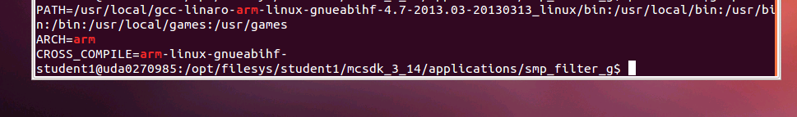

Make sure that the path to arm-linux-gnueabihf is defined and the arm-linux-gnueabihf is defined as the CROSS_COMPIER. If not, run the initialization script:

* Source /usr/local/staudentStartScript.sh

First build the project with full debug and no optimization:

* Make –f makefile_No_Optimization

Note that the optimization flag (dash capital O) is set to zero, and there is no –o (small o) thus the built project will have the default name a.out.

Before running the code you need to verify that the EVM is connected to the local network via Ethernet, which you have a terminal window (either Putty or Tera Term or other) into the EVM as explained in previous Labs, and that NSF boot from TFTP is working.

1. Power on the EVM
2. Wait for the login screen to come
3. Log as root:

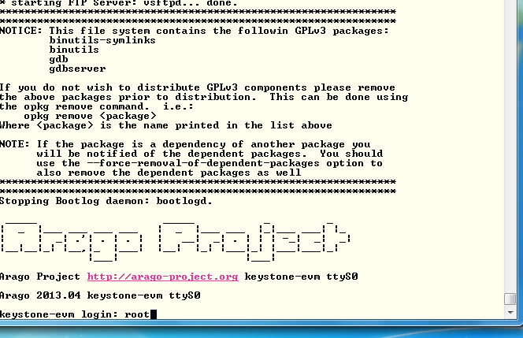

1. Change the location of the terminal to the smp_test directory:

* cd /applications/smp_test
* ls

The 4 source files, the three Make files and the a.out file should be in the directory.

1. To run the code with a single thread first ensure that the file a.out has executable permission

* chmod +x a.out

1. Run the code

* ./a.out 1

1. After a few seconds (wait until all the printing is done) the results should look similar to the follows:

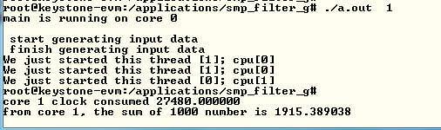

1. Record the clock consumed value in the table below
2. Back in the VNC window re-build the executable with O2 optimization:

* Make –f makefile_No_Optimization

1. And run a.out again. The results should look like the following:

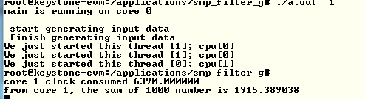

1. Back in the VNC window re-build the executable with full optimization:

* Make –f makefile_full_Optimization

1. And run a.out again.

Question

1. What is the speed up percentage of performance improvements when the optimization O2 is on?
2. What is the speed up percentage of performance improvements when the full optimization is on? - Compare to non-optimization, compare to –O2

## Task 3: Run the Code on Multiple Cores

From this point on you only run the fully optimized version of the a.out executable.

In this task you run the program on multiple cores. While the total processing time on all the cores remains almost the same, the elapsed time (the time that the slowest core consumes) will be reduced almost linearly by the number of cores that are involved.

The SMP operating system will distribute threads between cores. The number of thread in this program is limited to 32, but the number of cores is 4. So if the number of threads is bigger than 4, multiple threads will be assigned to each core.

Run the following cases and fill the table below:

* ./a.out 1
* ./a.out 2
* ./a.out 4
* ./a.out 8
* ./a.out 16
* ./a.out 32

|  |  |  |  |  |  |  |
| --- | --- | --- | --- | --- | --- | --- |
| Number of threads | Core 0 total time consumed | Core 1 total time consumed | Core 2 total time consumed | Core 3 total time consumed | Slowest core time consumed | Total time consumed by the 4 cores |
|  |  |  |  |  |  |  |
|  |  |  |  |  |  |  |
|  |  |  |  |  |  |  |
|  |  |  |  |  |  |  |
|  |  |  |  |  |  |  |
|  |  |  |  |  |  |  |

Question

1. The shared ARM L2 cache is 4MB. Are all the vectors fit into the cache?
2. The private L1 cache for each A15 is 32KB. What is the maximum input vector that will not cause L1 cache to be trashed?
3. What is the speed up when 4 cores are used compare to a single core?
4. How does the cache size effect the total time when multiple threads are used?

# Lab 10: Inter-Processor Communication (IPC)

## Projects and source code

The original files for this Lab are part of the MCSDK release. The student will copy MCSDK release into his private directory (studentN/MCSDK_X_XX) before changing any file.

## Purpose

The purpose of this lab is to demonstrate messages transfer between the ARM and the DSP cores. The source code may be a starting point for customer who needs sending messages and data between cores.

## Task 1: Run the demo from a Web Server

### Step 1

The file system that is loaded into the EVM should be tisdk based file system. Boot the EVM using NFS (mount) boot and wait until the display on the EVM gives the IP address of the board. Note that the display flips between several messages. IP address is one of the messages.

### Step 2

Open a terminal into the EVM and log in as root

### Step 3

From a computer that is on the same sub-net as the EVM, or from vnc into a computer that is on the same subnet as the EVM start Firefox (or any other browser) and put the ip address of the EVM as shown in the following screen shot. The EVM in the screen shot has ip address of 192.168.0.24.

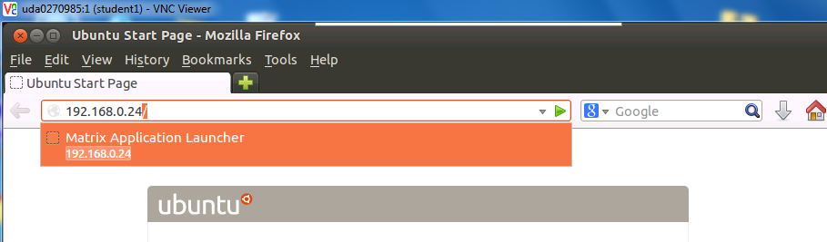

If the Firefox is connected via vnc, Ubuntu may ask you if you have a display device. Answer OK. The EVM respond with a set of out-of-the-box applications as seen in the next screen:

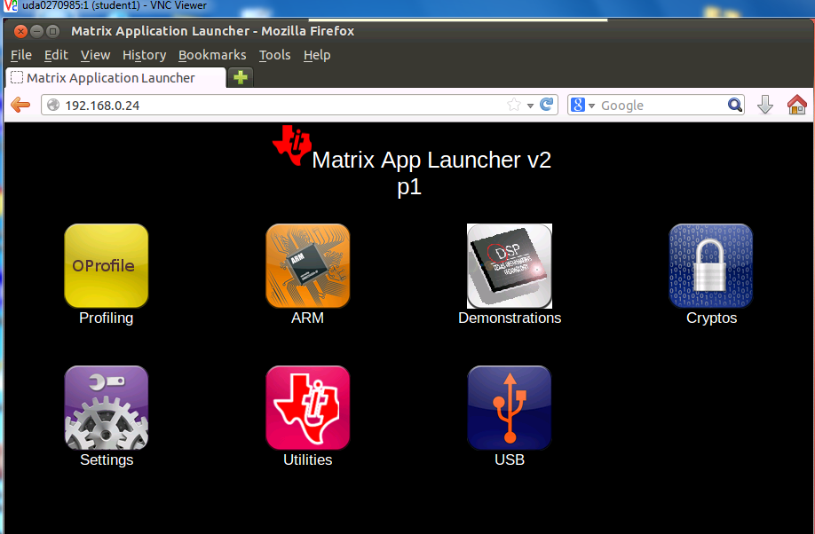

It is highly recommend going through each one of the applications, however, in this Lab we only use the IPC demo. Click on the Demonstrations tab and then the IPC Demo. The next screen shot will be displayed:

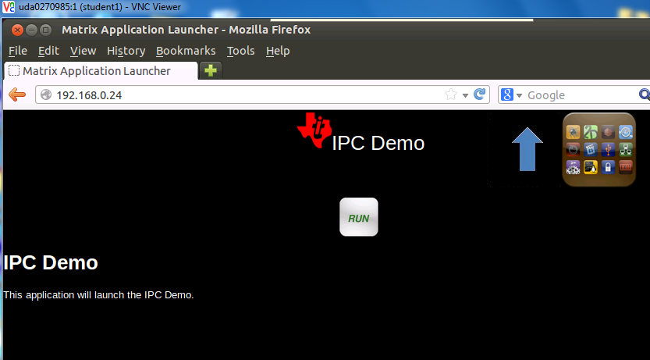

Click on RUN and follow the progress on the browser and on the terminal that is connected to the EVM.

The browser display

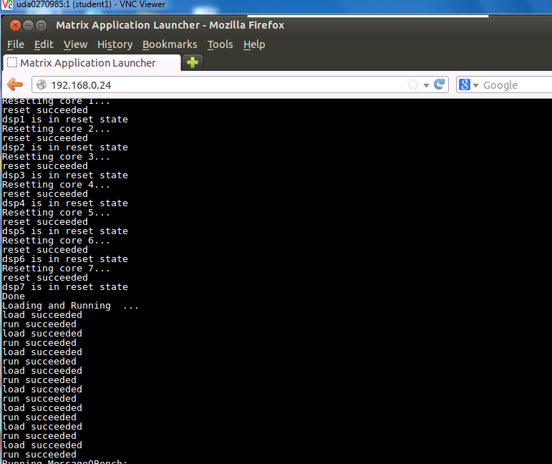

You may have to use the arrow to see the complete execution of the demo. The last lines are the following:

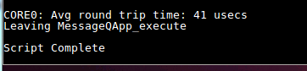

The terminal that is connected to the EVM displays something like:

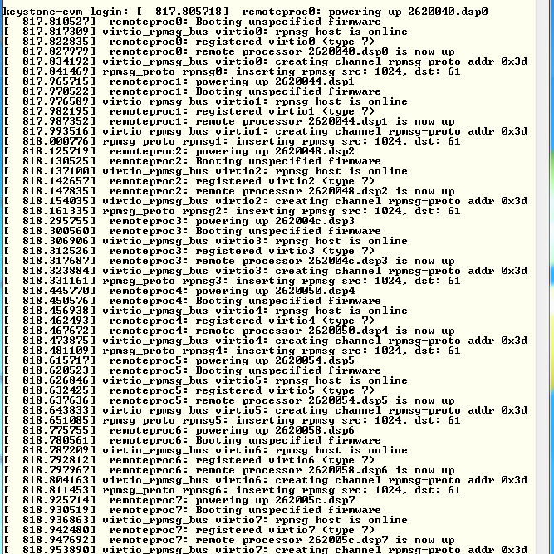

Follow the messages on the terminal and see what software modules are used (remoteproc, virtio, rpmsg)

## Task 2: Run the demo from the terminal

### Purpose

The purpose of this task is to familiar the user with the directory structure and the main files of the demo

### Step 1 – Understand the file demo_ipc.sh

In the directory /usr/share/matrix-gui-2.0/apps/demo_ipc there are three files demo_ipc.desktop, demo_ipc.sh, and desc_demo_ipc.html. Look at the file demo_ipc.sh using either vi, more, less, cat or any other utility. The screen shot was taken using cat:

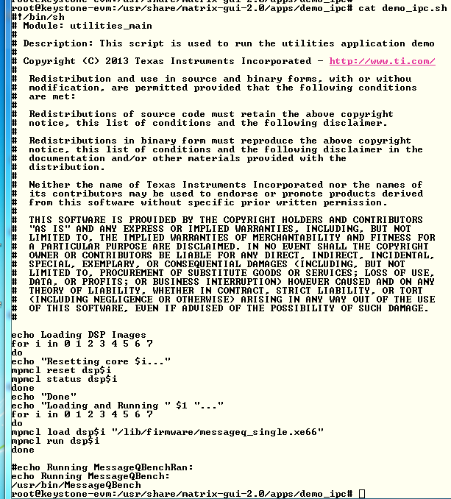

Notice that the DSP code is loaded from directory /lib/firmware and the name of the execution is message_single.xe66. The Linux code is loads from directory /usr/bin and the executable name is MessageQBench. In the next task you will build these two executable files in your local directory and move them to your private filesystem

### Step 2 – Run the file demo_ipc.sh

In the terminal, move to directory /usr/share/matrix-gui-2.0/apps/demo_ipc (cd /usr/share/matrix-gui-2.0/apps/demo_ipc ) and run the sh file ./demo_ipc.sh as in the following screen shots:



After the run the terminal looks like the following:

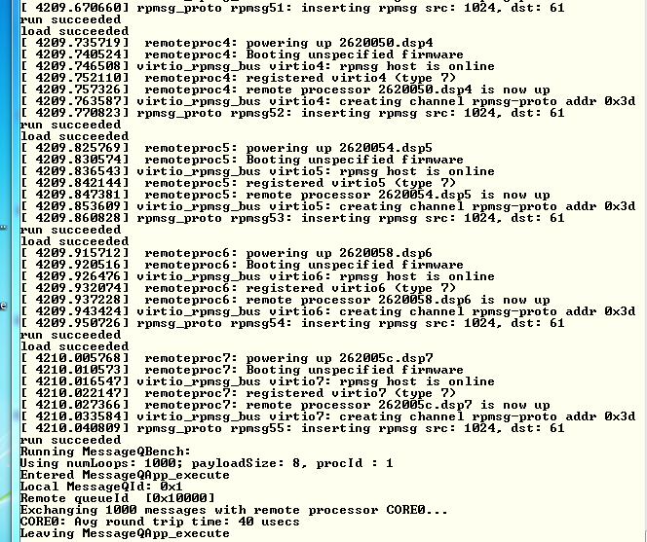

## Task 3: Rebuild the Executable

### Purpose

In this task the student will re-build the DSP and ARM executable to prepare for modifying the code for a new project

### Step 1 – Get a private copy of IPC from the release

In your home directory /home/studentN create a new directory named IPC and move there

* sudo mkdir IPC
* cd IPC

Copy the ipc directory from the latest release into the new created private directory. Currently the latest release is release 3_15

* sudo cp -R /opt/ti/MCSDK_3_15/ipc_3_00_04_29 / .
* cd ipc_3_00_04_29
* ls

The directory should look like the following:

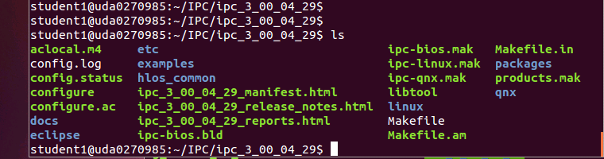

### Step 2 – Build the ARM executable

Detailed instructions how to install and build the Linux version of IPC are in the file IPC_Install_Guide_Linux.pdf that is part of the release in directory \MCSDK_3_15\ipc_3_00_04_29\docs. The install part of the IPC is already in the release, so we will start with the build procedure.

First a set of environment variables should be set in the file products.mak in the directory ipc_3_00_04_29 (or any later version of the IPC). The following is a list of environment variables that need to be updated:

TOOLCHAIN_INSTALL_DIR

TOOLCHAIN_LONGNAME

PLATFORM

XDC_INSTALL_DIR

BIOS_INSTALL_DIR

ti.targets

The user guide from above explains what needs to be set in the variables that are mentioned above. The following is an example of the definition. You may have to modify the variables based on structure of your system

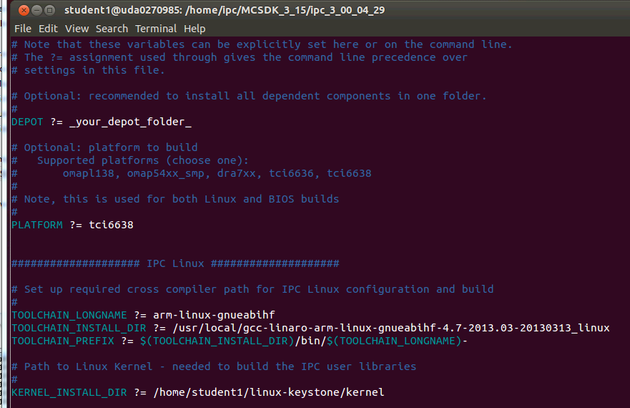

The platform is tci6638 (Hawing). The TOOLCHAIN_INSTALL_DIR is the location where the Linaro tools were installed on the server. The KERNEL_INSTALL_DIR is where the kernel sources were installed using the git repository. Instructions how to install the kernel sources using the git repository are given in Lab 2 task 2 of the KeyStone II Multicore Workshop Arm-Based Lab manual.

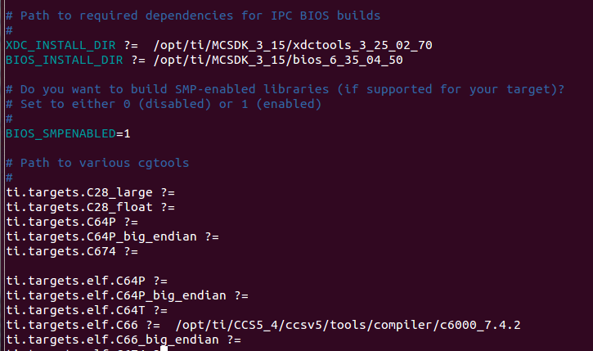

XDC)INSTALL_DIR is part of the MCSDK release and the location points to where MCSDK was installed. The same is true for the BIOS_INSTALL_DIR. The ti.targets.elf.c66 is the location of the code generating tools for this platform. The tools location is part of the CCS release. The CCS was installed in /opt/ti /CCS5_4 directory.

In order to manipulate files in the ipc directory you have to change the permission. Since this is a private copy on a local network, you can give full permission

* cd ..
* sudo chmod 777 –R ipc_3_00_04_29
* cd ipc_3_00_04_29

The first step is cleaning the older build:

* sudo make clean

Next step is to run the make utility with the linux makefile:

* make –f ipc-linux.mak config

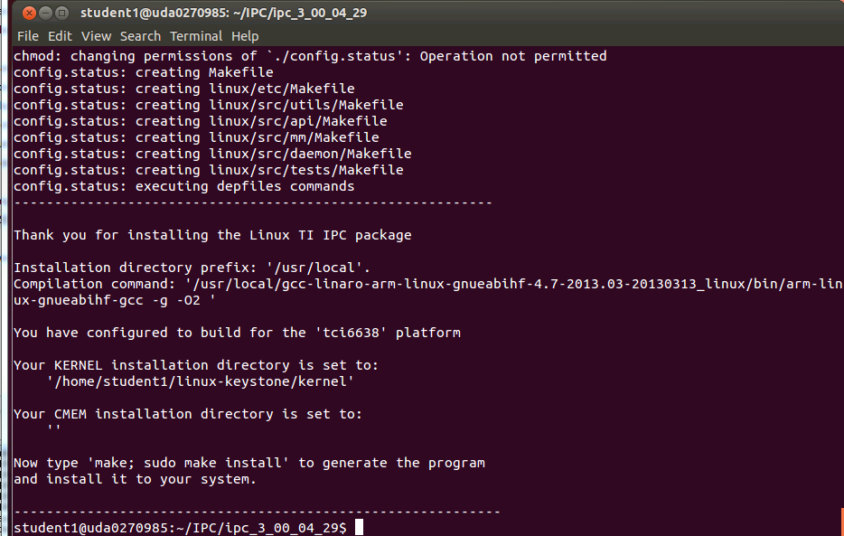

The screen prompts you to run the next make

* make ; sudo make install

Follow the printing in the window. It may ask you for a password for the sudo part. The following screen shot shows the end of the build. In case of error, see the note after the screen shot.

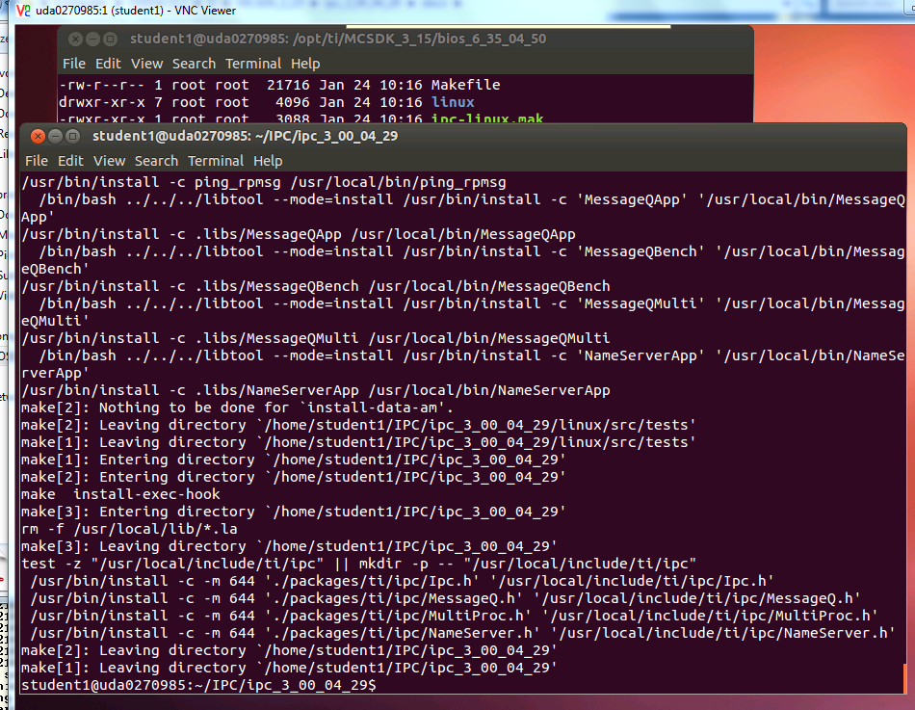

Note – some of the libraries may not be rebuilt, but the output files are built. The screen shot may be like the following:

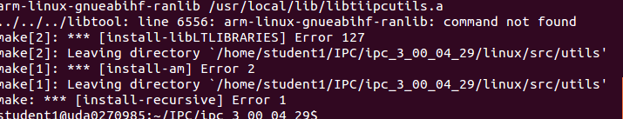

The build process builds several files. The file MessageQBench in directory linux/src/tests/ is a temporary wrapper script file that shows how the build is done. The file MessageQBench (yes, the same name) in directory linux/src/tests/.libs is the executable. After the build move this file to the file system location

* sudo cp linux/tests/.libs/MessageQBench /opt/filesys/studentN/mcsdk_x_xx/usr/bin/.

Verify that the executable in the /opt/filesys/studentN/mcsdk_x_XX/lib/usr/bin directory is the one that you built by doing ls –ltr MessageQBench and verify the data and time

### Step 3 – Build the DSP executable

Detailed instructions how to install and build the DSP-BIOS version of IPC are in the file IPC_Install_Guide_BIOS.pdf that is part of the release in directory \MCSDK_3_15\ipc_3_00_04_29\docs. The install part of the IPC is already in the release, so we will start with the build procedure.

The environment variables in the file products.mak were already set in the previous step.

Return back to the ipc directory

Next step is to run the make utility with the linux makefile:

* cd ~/IPC/ipc_3_00_04_29 (or a newer version of IPC)
* make –f ipc-bios.mak all

The build will take several minutes. The following is a screen shot when the build is done:

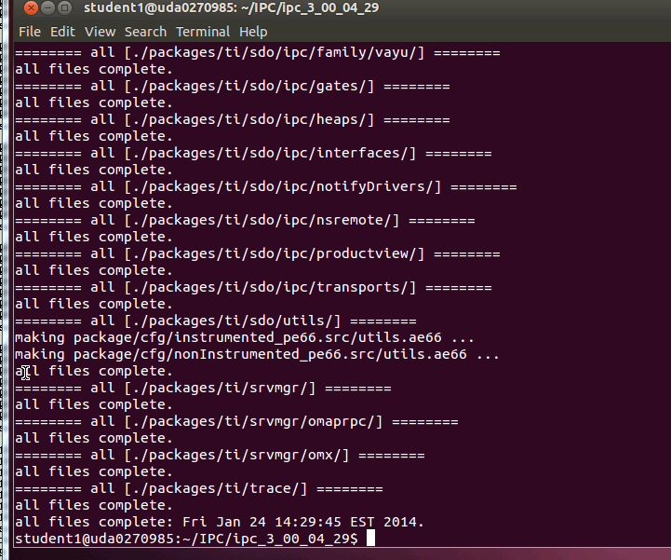

The executables are built in the directory IPC/ipc_3_00_04_29/packages/ti/ipc/tests/bin/ti_platforms_evmTCI6638K2K. There are 5 executables as follows:

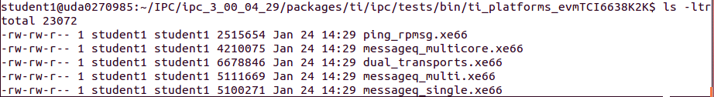

The file messageQ_signal.xe66 should be copied to the file server at location /opt/filesys/studentN/mcsdk_x_XX/lib/firmware

* sudo cp packages/ti/ipc/tests/bin/ti_platforms_evmTCI6638K2K/messageq_single.xe66 /opt/filesys/student1/mcsdk_3_14/lib/firmware/.

Verify that the executable in the /opt/filesys/studentN/mcsdk_x_XX/lib/firmware directory is the one that you built by doing ls –ltr messageQ_single.xe66 and verify the data and time

## Task 4 – Optional: Modify source code and rebuild the executable

### Purpose

In this task the student will change the ARM code and the DSP code, build and run the executable

### Step 1 – Modify the ARM code

The demo source file is MessageQBench.c in directory /IPC/ipc_3_00_04_29/linux/src/tests. Following the source file, it looks like the ARM allocates a message, sends it to the DSP, and then gets the message back and make sure that the data was not corrupted during the transfer. The changes that are suggested for the ARM side are the following:

1. Modify a printf statement to show that the code has been modified
2. Adding an additional value (or values) to the message, load the additional value with a known data, and print the additional information from the DSP side

Here are the suggested changes:

1. Add two more values to the message:

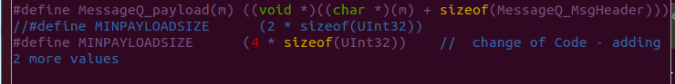

1. Load the additional value with whatever you wish, in the example it is 0xbadface

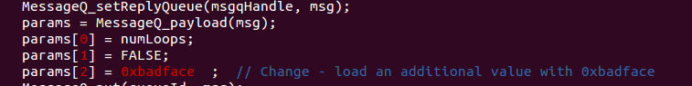

1. Modify the print statement

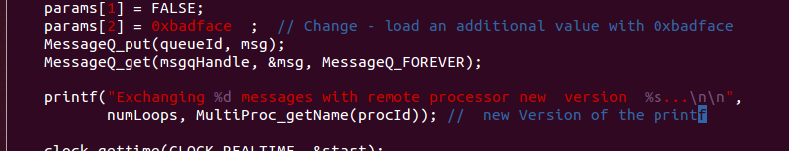

### Step 2 – Build the ARM code

Repeat the steps from the previous task and re-build the ARM executable MessageQBench

### Step 3 – Modify the DSP code

The DSP source function messageq_single.c is in directory IPC/ipc_3_00_04_29/packages/ti/ipc/tests .

1. Add a new variable newValueAdded to the tsk1Fxn

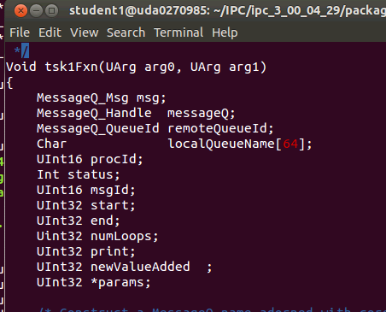

1. Load the newValueAdded with the last value in the receive message from the ARM

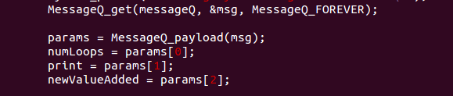

1. Print the value of the newValueAdded

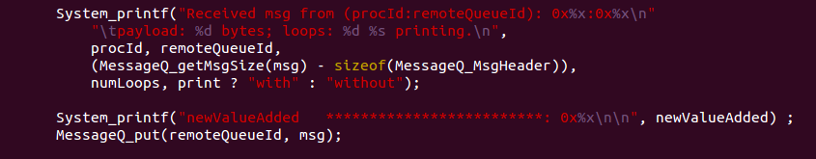

### Step 4 – Build the DSP code

Follow the instructions from the previous task

### Step 5 – Run the file demo_ipc.sh

Follow the instructions of task 2

1. Observe the printing on the terminal to see the changes that you did in the printf of the ARM code
2. Look at the ARM trace buffer of DSP core 0 to see if the added value is printed. Look at

* Cat /debug/remoteproc/remoteproc0/trace0

The value in newValueAdded should be printed in the trace (in addition to other printings)

# Lab 11: Build U-boot, Boot Monitor and Kernel

Linux distribution enables users to download all source code and build the Linux components. This optional task gives instructions how to do so.

TI uses the Arago distribution on a public server to store all source code. The user can download all the sources and make files to build all images in the release. The Ubuntu server must be connected to the network to facilitate downloading of the source code. If the server is behind a firewall, proxies must be set. These proxies are defined already in the /usr/local/training/studentScript.sh script.

# U-BOOT source code extraction and build instructions

Before getting the source, the user must be in his home directory. Cloning the source code will generate sub-directories.

*cd ~/* back into the home directory /home/studentN

*git* clone git://git.ti.com/keystone-linux/u-boot.git u-boot-keystone . This instruction will clone the repository into your local directory ~/u-boot-keystone

*cd u-boot-keystone*  change directory to where the sources are

*git reset --hard label* Where label is the label that is attached to the current release. To find the head label the user should look at the release notes. For MCSDK 3_14 the label is ***K2_UBOOT_2013-01_13.09_01*** so the reset instruction for the current release will be the following

*git reset –hard K2_UBOOT_2013-01_13.09_01*

Different versions of the U-BOOT can be built, depends how the code is loaded. U-BOOT can be loaded from code composer studio, or from boot methods and the format can either be u-boot.bin, u-boot.img, u-boot-spl.bin or u-boot-spi.gph (The different formats are discussed in the boot loader presentation)

option a: if using CCS to load (u-boot.bin)

*make tci6638_evm_config*

*make*

option b: if using the two stage SPI NOR boot

*make tci6638_evm_config*

*make spl/u-boot-spl.bin*

*make tci6638_evm_config*

*make u-boot.img*

*make tci6638_evm_config*

*make u-boot-spi.gph*

## Boot Monitor (skern.bin) source code extraction and build instructions

Before getting the source, the user must be in his home directory. Cloning the source code will generate sub-directories.

*cd ~/* back into the home directory /home/studentN

*git clone git://git.ti.com/keystone-linux/boot-monitor.git*

This instruction will clone the repository into your local directory ~/boot-monitor

*cd boot-monitor* change directory to where the sources are

*git reset --hard label* Where label is the label that is attached to the current release. To find the head label the user should look at the release notes. For MCSDK 3_14 the label is K2_BM_13.08 so the reset instruction for the current release will be the following

*git reset --hard K2_BM_13.11*

*make clean*

*make*

## Linux Kernel and device tree source code extraction and build instructions

Before getting the source, the user must be in his home directory. Cloning the source code will generate sub-directories.

*cd ~/* back into the home directory /home/studentN

*git clone git://git.ti.com/keystone-linux/linux.git linux-keystone* This instruction will clone the repository into your local directory ~/boot-monitor

*cd linux-keystone* change directory to where the sources are

*git reset --hard label* Where label is the label that is attached to the current release. To find the head label the user should look at the release notes. For MCSDK 3_14 the label is *K2_LINUX_03.08.04_13.09_01* so the reset instruction for the current release will be the following

*git reset --hard K2_LINUX_03.10.10_13.11_01*

*make keystone2_defconfig*

*make uImage*

*make keystone-sim.dtb*

*make tci6638-evm.dtb*

The built files:

vmlinux is in /linux-keystone folder:

uImage